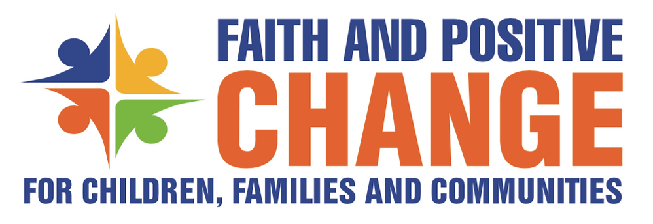

FPCC Regional Faith Engagement Forum for South Asia
8-10 May 2022
Kathmandu Statement

We, the participants of the Faith and Positive Change for Children, Communities and Families (FPCC) Regional Faith Engagement Forum for South Asia, have come together to share and address pressing issues related to children in a holistic manner through integrated approaches and framework. As tripartite partnership of Religions for Peace, faith-based organisations and UNICEF, we are committed to identify common actions for the well-being of children in South Asia. We are committed to pursuing the essential role of religious communities and faith actors in bringing about a sustainable positive social and behaviour change in complex behaviours and social norms that affect child health, protection and development outcomes.

This FPCC Regional Faith Engagement Forum, convened by UNICEF, Asian Conference of Religions for Peace and Joint Learning Initiative on Faith and Local Communities, is a continuing effort of the tripartite partners to implement the principles and commitments, and build on the outcomes and learning experiences of the South Asia Regional High-Level Summit of Faith Actors on 8 December 2021, and the Global Workshop on Faith for Social and Behaviour Change on 10-12 July 2018 in Bangkok Thailand, in line with the 2023 Sustainable Development Goals (SDGs).

Religion is at the heart of people’s values and identities in the diverse cultures of South Asia, which constitutes around 1/4 of the global population with 650 million children. Religious beliefs are deeply entrenched in their daily life influencing their views, and family and community practices. For these reasons, religious communities, through the various constituencies of faith actors from religious leaders to parents to children themselves, can significantly and effectively move the hearts and minds of communities, and contribute to social cohesion and resilience.

Understanding that the tripartite partnership, through its shared resources and unique comparative strengths and capacities, will be more effective in achieving results for children, families and communities, the partners will –
- Collaborate to provide a better environment for children to develop their best potential and promote their wellbeing based on the diverse spirituality and faith traditions of South Asia.
- Work together on an evidence-based integrated framework for faith-based leadership, and a collective decision-making process in creating, strengthening, and sustaining safe and protected environment for children.
- Set up a strategic, sustainable, and effective partnership with religious leaders, local faith communities, and faith-based organisations through a new way of working that is more collaborative, community-asset based, integrated, and holistic

We commit to –
- Engaging existing faith networks in the region in a consultative, inclusive, and coordinated way to facilitate strengthened collaboration between religious leaders, faith-based organisations and international organisations to advance child rights and wellbeing.
- Building the capacity of faith leaders, the women of faith, and interfaith youth networks, and equipping them with resources to enable them effectively address key issues and concerns on child rights and wellbeing.
- Advocating for policy change through child-welfare and protection legislation, and positively engage the government at various levels for the enforcement of laws to protecting child rights.
- Increasing our social and traditional media presence to highlight the issue, successes, and lessons learned for the promotion and protection of child rights and wellbeing.

We affirm we will translate these commitments that we have made in Kathmandu and at the December Summit through –
- Mapping faith engagement work of various organisations in the region to further strengthen collaboration between and among faith leaders, faith-based organisations and other institutions that are working to advance child rights.
- Operationalising the Regional Faith Engagement Strategy and Action Plan developed at this Forum.
- Supporting the newly constituted South Asia Regional Advisory Group to coordinate the South Asia tripartite collaboration and implement the regional faith engagement strategies.
- Establishing the national level Multi-Faith Action Committees for Children, Families and Communities (MFACC) that is inclusive of all religious groups and faith actors as mechanisms for collaboration and engagements to support joint action planning, implementation and monitoring.

We, who have gathered here from Afghanistan, Bangladesh, Bhutan, India, Maldives, Nepal, Pakistan and Sri Lanka, will continue to work to empower children, families, and their communities towards culturally and spiritually enriched environment for the dignity and wellbeing of all children.

