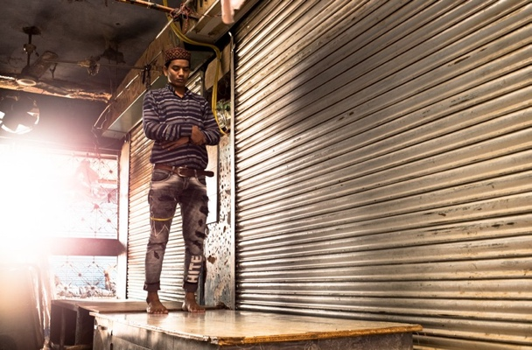
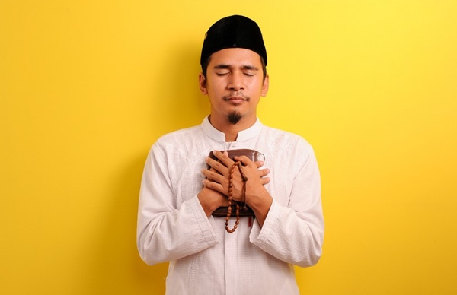
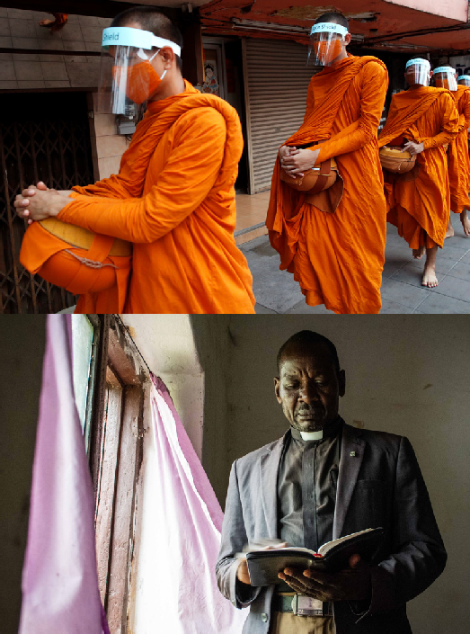
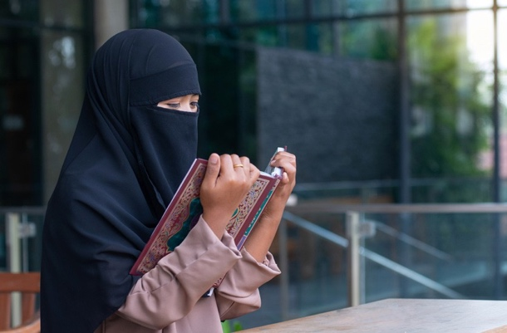
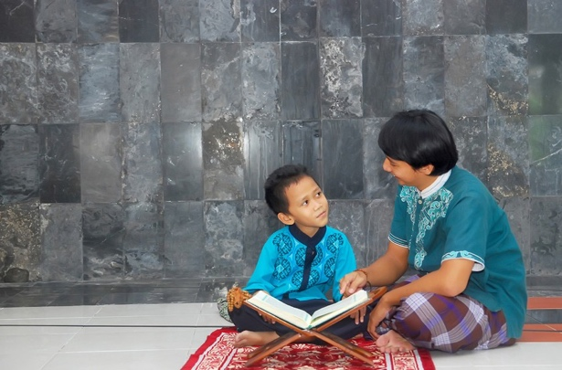
COVID-19
PRACTISING OUR FAITH SAFELY DURING A PANDEMIC

COMMUNICATING TO END MISINFORMATION, DISCRIMINATION AND TO INSTILL HOPE

Resource Guide for Religious Leaders and Faith Communities

Cover photo credits (clockwise):

Bangkok / Thailand April 2, 2020: Thai Buddhist monks wearing face shields to protect themselves from Covid-19 collect morning alms By Thavorn Rueang

Muslim woman reading Holy Quran praying for God to bless her in a public place By chomplearn

Portrait of male surgeon praying in an operation theater at a hospital. Healthcare workers in the Coronavirus Covid19 pandemic By wavebreakmedia

A young Asian father teaches a child to read the Holy Quran By Aidil Akbar

A priest and a devotee wear masks and maintain social distance while offering prayers at a temple in Ghaziabad, Uttar Pradesh, India By Ashutosh Sharma

A woman, holding a holy text, bows her head with her hands raised in prayer By UfaBizPhoto

Migrant labourers who failed to reach their native villages after lockdown offer (Namaz) prayers besides the closed shop where they used to work.
By A. Mukjherjee

A portrait of a man holding Holy Quran and prayer beads By Heru Anggara

A woman raises her hands in prayer, seated in the pews of a church By frantic00

Reverend Tito Ringanza, the Provincial Secretary of Episcopal Church of South Sudan, reads a Bible at his office in Yambio,
South Sudan, March 2020. Rev. Tito’s mother died in the 1976 Ebola outbreak. Reverend Tito’s church spends time during church services to educate people on how to take care and protect themselves from Ebola virus.
By Brian Ongoro

BACKGROUND ON THE GLOBAL MULTI-RELIGIOUS FAITH-IN-ACTION COVID-19 INITIATIVE

Faith and Positive Change for Children, Families and Communities (FPCC) https://www.faith4sbcc.org/
is a global partnership between the United Nations Children’s Fund (UNICEF), the world’s largest inter-faith network Religions for Peace (RfP), and knowledge partner Joint Learning Initiative on Local Faith Communities (JLI). FPCC was conceived in 2018 to move beyond single sector, siloed, ad-hoc and sometimes instrumentalist approaches of faith engagement in development work and was officially launched by RfP and UNICEF’s Executive Director in Washington DC in October 2019.

The central aim of the partnership is to support positive social and behaviour change with and for children, parents and communities with specific emphasis on going beyond simply delivering messages, to engaging faith communities in self-reflection, dialogue, exchange and feedback in order to achieve lasting positive change on jointly agreed priorities affecting children and their families. After a year of evidence generation, development of 17 country case studies, reviews of existing resource guides and development of a Theory of Change, the partners agreed to work together more systematically and deeply in keeping with the new engagement model in six African “Early Adopter Countries”.

In the last quarter of 2019, a process of country level “WorkRocks” was initiated to pilot the new way of coordinating planning and action of UNICEF country offices with their respective Inter-Religious Councils and the local offices of international faith-based organizations.

In February 2020, in response to the COVID-19 worldwide pandemic, the FPCC partners agreed to immediately shift focus of its joint workplan to
respond to the international crisis through a new global multi-religious Faith-in-Action initiative to provide coordinated and evidence-based inter-faith support
for the protection and well-being of children and their communities. UNICEF’s Executive Director signed a joint global statement and call to action on the COVID-19 response with 12 of RfP’s most senior religious leaders. https://rfp.org/launch-of-global-multi-religious-faith-in- action-covid-19-initiative-2/ https://www.unicef.org/press-releases/launch-global- multi-religious-faith-action-covid-19-initiative.

The initiative aims to mobilize religious leaders, faith communities, women of faith, and youth networks within RfP through its Inter-Religious Councils at country level to support COVID preparedness and response.
The key objectives of the campaign are to:

- Manage communication, address misinformation and rumours
- Dispel fear, stigma, discrimination, and promote social harmony
- Promote adaptation of religious gatherings, practices, rituals, handwashing and hygiene
- Address specific needs of vulnerable groups
- Promote the prevention of violence against children and women
- Promote the participation of children and young people and their active engagement in the initiative
- Promote and support the recovery of social services, resilience and return to normalcy

In order to achieve the above objectives, the Faith-in- Action initiative has outlined the following strategies:

- High level advocacy at global, regional and country level
- Generation and analysis of faith-related behavioural evidence to inform action
- Development, dissemination and local customization of global guidance on key thematic issues
- Periodic webinars at the different levels for sharing of knowledge, issues and experiences
- Digital engagement and capacity development
- Tracking, monitoring and documentation of the results of the initiative.

Working with UNICEF, RfP and many other partners, JLI developed a Global Reference Document https://jliflc.com/resources/multi-religious-faith-in-action- covid-19-initiative-reference-document-ed-1/ to inform the development of series of COVID-related specific thematic guides.

This package of thematic Guides is aligned with and are expected to support the achievement of each of the 7 objectives of the Multi-Religious Faith-in-Action
COVID-19 global initiative as outlined in the background. The Guides have been designed specifically for use, updating and adaptation by religious leaders, faith communities and FBOs at country and community-level with support from UNICEF and other humanitarian and development partners to support the implementation of the Faith-in-Action initiative.

For questions on the guides please contact: Kerida McDonald kmcdonald@unicef.org Deepika Singh dsingh@rfp.org

1

ACKNOWLEDGMENTS

This Faith-in-Action guidance document would not have been possible without the invaluable inputs of many colleagues from the three main partner agencies that contributed to the development and compilation. We take the opportunity to acknowledge and express appreciation to the main writers and reviewers:

Joint Learning Initiative:
Olivia Wilkinson, Jean Duff, Stacy Nam, Susanna Trotta, Ellen Goodwin

Religions for Peace (RfP):
Deepika Singh, Dr Francis Kuria, Jimmy Otieno,
Kyoichi Sugino, Sarah van Bentum, Maddalena Maltese, Mary Grace Donohoe and Christopher Zefting

UNICEF:
Kerida McDonald, Carlos Navarro Colorado, Sonia Sarkar, Ivan Amezquita, Julianne Birungi, Ken Dawson, Massimiliano Sani, Johary Randimbivololona,
Sahar Hegazi, Ken Limwame, Christine Heckman, Eric Dentor, Mariana Zaichykova

UNICEF Interns:
Snigdha Suvarna (Occidental U.), Ishanya Anthapur and Shanaz Deen (Princeton U.)

C4D Consultant:
Ami Sengupta

In addition, we would like to express gratitude to all the religious leaders and organizations that supported the review and feedback on the documents in alphabetical order by organization

Religious Leaders, Religions for Peace:
Bhai Sahib Mohinder Singh, Prof. Anantanand Rambachan, Ms. Bani Dugal, Mr. Homi D. Gandhi, Ms. Ravinder Kaur Nijjar

International Faith Based Organizations and Associates:
  - ACT Alliance, Thorsten Göbel
  - Adventist Development & Relief Agency, Imad Madanat, Sonya Funna
  - Anglican Alliance, Rachel Carnegie, Janice Proud
  - Arigatou: Rebecca Rios-Kohn, Maria Lucia Uribe
  - American Jewish World Services, Ruth Messinger
  - Dan Church Aid, Jørgen Thomsen
  - Emory University Interfaith Health Program, John Blevins
  - Episcopal Relief and Development, Abagail Nelson, Nagulan Nesiah
  - Humanitarian Forum Indonesia, Yusuf Ali, Dear Sinandang

- FADICA, Alexia Kelley
- Islamic Relief Worldwide, Atallah Fitzgibbon
- Kirk In Actie, Corrie Van der Ven
- Mothers Union, Rob Dawes
- Organization of African Instituted Churches, Rev Nicta Lubaale
- Sally Smith
- Soka Gakkai, Noboyuki Asai
- Salvation Army, Bram Bailey
- Sarvodaya, Vinya Aryaratne
- Tearfund, Catriona DeJean
- World Council of Churches, Masimba Kuchera, Frederique Seidel
- World Evangelical Alliance, Christine McMillan, David Boan
- World Faith Development Dialogue, Katherine Marshall
- World Vision International, Andrea Kaufmann

Development Agencies:
- Gratitude is due to the following individuals from development agencies who provided inputs for the guides:
- Food for the Hungry, Luis Noda
- Global Water 2020, Lindsay Denny
- International Federation of Red Cross and Red Crescent, Amjad Saleem
- USAID CFOI, Kirsten Evans
- US Dept Health and Human Services, Heidi Christensen
- WHO, Sarah Hess
- World Bank, Mercy Niwe

Design and Photography:
We are grateful to Donna Rajeh for the design and layout of the document, to Fortuneight Pvt. Ltd for their voluntary support for the abridged slide decks and strategic inputs to the guidelines, to Ashutosh Sharma, Anandito Mukherjee, and Thomas Sampson, for many of the original photographs.

Translation and proofreading:
Special thanks also to SIL International who voluntarily assisted with proofreading of the English language documents and translation of the slide decks of the guidelines into other languages. The team was led by Paul Frank.

2

CONTENTS

BACKGROUND ON THE GLOBAL MULTI-RELIGIOUS FAITH-IN-ACTION COVID-19 INITIATIVE
1

2 ACKNOWLEDGMENTS
7 ISSUES

WHAT CAN RELIGIOUS LEADERS AND FAITH COMMUNITIES DO
9

RELEVANT
13
RELIGIOUS TEACHINGS

IDEAS FOR DIALOGUE AND ACTION
15

ADDITIONAL RESOURCES
16

JOINT CALL TO ACTION
17
3

YOUR ROLE AS A RELIGIOUS LEADER OR FAITH RESPONDER COMMUNICATING TO END MISINFORMATION, DISCRIMINATION,
AND FEAR

Series 2: Resource Guide for Religious Leaders and Faith Communities

COMMUNICATING TO END MISINFORMATION, DISCRIMINATION AND TO INSTILL HOPE

COMMUNICATING TO END MISINFORMATION, DISCRIMINATION AND TO INSTILL HOPE

ISSUES

Ensuring trust, mental health, spiritual guidance, and social support are essential during a pandemic, when people are coping with intensified levels of fear, uncertainty, loss, and anxiety. Based on their trusted position, religious leaders are seen as reliable sources of information in communities. Religious leaders have significant influence over the attitudes, beliefs and behaviours of their followers and the wider community. In times of crisis, religious leaders can provide spiritual guidance and support when solidarity, hope and empathy is needed most.

In the context of health outbreaks such as COVID-19, religious leaders also have an important role in tackling stigma and discrimination resulting from misinformation and from targeting specific individuals or groups of people associated with the disease. In order to carry out this important role, religious leaders need to equip themselves with a better understanding
of some of the contributing factors and negative effects of misinformation, rumours, fear, hopelessness, stigma, and discrimination.

Address misinformation and rumours
  - Inadequate knowledge of the disease: While information about the pandemic is prominent on the news, people do not always have enough
information about what precautions to take or what symptoms to watch out for. For example, people know that the virus has flu-like symptoms, but they may not be aware of the specific symptoms, such
as breathing difficulties. People with limited access to the media may have even less information and may not be able to keep themselves updated with current and correct information.
  - Misinformation, myths and rumours: When there is a new disease with a lot of unknown factors, myths and misinformation tend to spread. Some
of myths and misinformation include the idea that people who are young and healthy will not get the disease, that God will protect them from the disease, that the disease will not spread in hot climates, or that the source of the disease is meat.
Some believe that they can be protected from the disease by soaking in the sun, drinking hot drinks or alcohol, or using herbal remedies.
  - Perceived low risk: In many cases, even when people know the dangers of the disease, they tend to feel they are at low risk of infection and do not
need to take precautions. People may feel a false sense of safety because no one they know has the virus and it is not in their area or they do not have any symptoms.

Prevent discrimination and stigma
- Misinformation and fear lead to stigma: Sometimes the fear, confusion, panic, and helplessness that people experience during a
pandemic can lead to false assumptions, blaming, stigmatization, discrimination, and at times violence. Certain groups of people are facing stigma and discrimination related to COVID -19, and these include those infected by the virus and their family members, people from Asian countries, people who have travelled, emergency responders, healthcare professionals, people from different religions, as well as migrants and refugee populations.
- Language that promotes stigma: Certain words, such as “suspected cases” or “victims”, make those affected sound as if they are powerless, nameless
objects rather than people with agency, and can reinforce stigma and negative stereotyping. Using criminalizing or dehumanizing words creates the feeling that those with the disease have somehow done something wrong or are less human
than others.
- Stigma hinders the medical response to COVID-19: In the context of an outbreak, stigma can worsen the situation, as a person who is ill or has a family
member experiencing symptoms may hide the illness and avoid seeking health care. They may also be excluded from receiving basic services, including housing, employment, healthcare, food, and education. This can further the spread of the pandemic and put people at greater risk.
- Mental stress of people affected by stigma: Stigma and discrimination create negative emotions within families and amongst communities. Avoidance,
neglect, or rejection related to stigma adds to the emotional and mental stress that people are already experiencing as a result of the disruptions of
normal life.

7

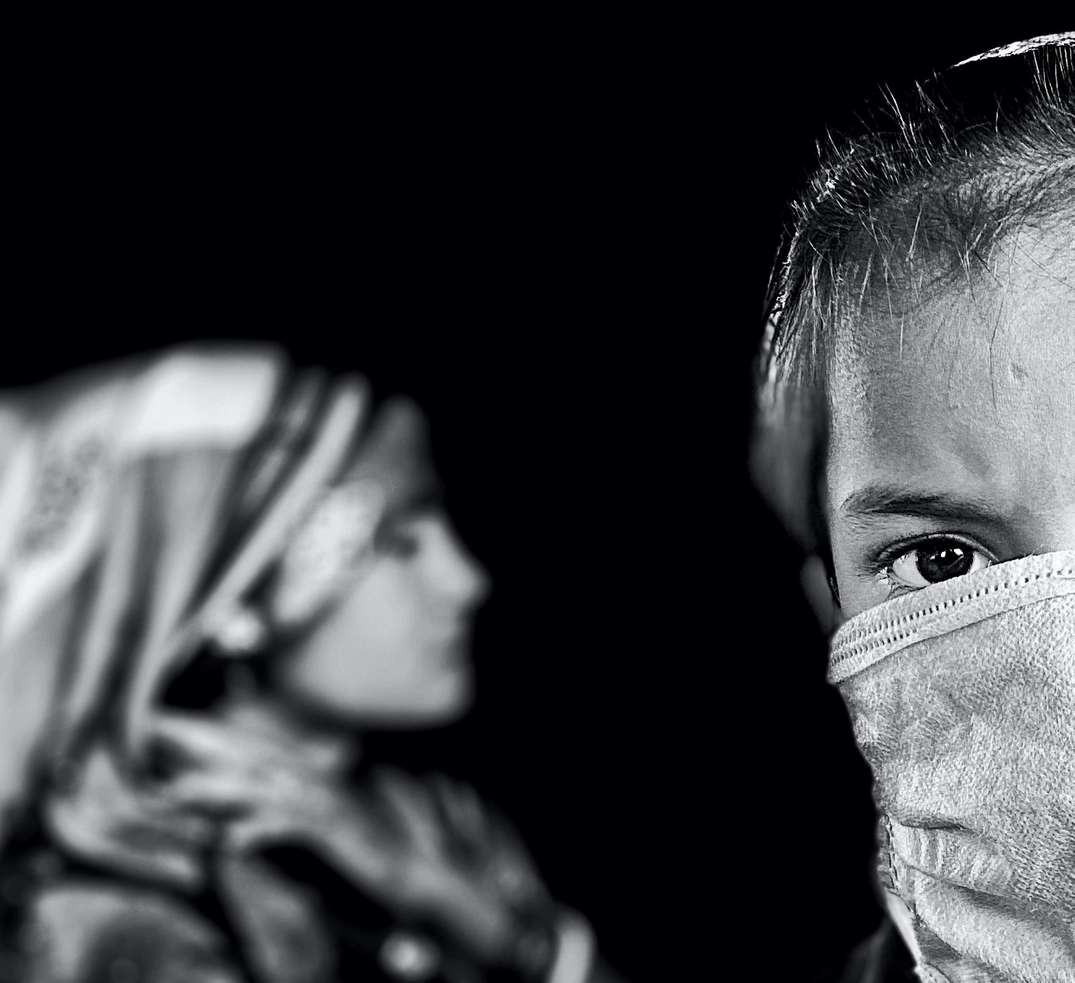
COMMUNICATING TO END MISINFORMATION, DISCRIMINATION AND TO INSTILL HOPE

Communicate hope and spiritual support
  - Mental and emotional stress: The pandemic has created immense stress for people of all ages across the globe. Many factors are causing mental and
emotional stress, including the fear of becoming infected; anxiety about elderly relatives getting sick; grief over lost loved ones; and uncertainty of how long it will take for things to return to normal or whether this is possible. Social isolation also leads to loneliness, boredom, and frustration about being separated from friends and family, and anxiety over disruption of normal routines. For many people, concerns about loss of incomes, pending bills, and
food shortages can cause further stress. A child waits at the bus station for over two days with her mother
during the lockdown in Greater Noida, Delhi. By: Anindito Mukherjee, New Delhi

8

WHAT CAN RELIGIOUS LEADERS AND FAITH COMMUNITIES DO

Address misinformation and rumours

Ensure accurate information
  - If religious leaders receive information on COVID-19, they should double-check the facts before sharing and ensure that any messages sent out by their
community or organization is accurate and consistent.
  - Religious leaders should provide the sources of their information and share messages from national health authorities, checking they are also in line
with messages from the WHO and UNICEF.
  - Keep up-to-date with the latest information, as the nature of the pandemic changes rapidly and so do related guidelines.

Fight against misinformation, myths, and rumours
  - Speak out against false information.
  - Communicate information on the COVID-19 in a way that does not exacerbated panic and fear. Avoid using words such as “the plague”, “apocalypse”, “the
numbers dying have spun out of control” etc.

Encourage faith communities to promote science alongside faith
  - While promoting hope and trust in the divine to get through the crisis, emphasize the importance of abiding by the public health regulations and
guidelines, especially in relation to religious services, mass gatherings and religious practices and rituals.
  - Dialogue with traditional healers and seek their commitment to following health and hygiene practices; report on infected persons in the
interest of containing the spread of the disease and refer people to health facilities if someone has breathing difficulties.
Prevent discrimination and stigma
- Ensure messaging that respects people’s rights that is respectful and free of prejudices towards any specific population group, based on age, origin, or
disability or tracking/testing status.
- Identify and listen to those affected by discrimination by creating opportunities where the disease and its impact can be discussed openly and
honestly. Engage faith communities in dialogue with stigmatized groups and consider how best to support them. Simultaneously promote empathy among
the broader community towards these groups. You may draw on your Scriptures, for example reminding people that the Prophet Mohammed (PBUH) said, “Do not cause harm or return harm.”
- Speak up and take action when people are not treated fairly or stigmatized. Support individuals who have the virus and are ill, hospitalized or have
recovered. They can become positive examples of how medicine, faith, and community come together.
- Address negative voices within your communities of faith, by setting aside time to discuss sensitive issues. This can also be done through inter-faith
platforms, to help create understanding between different groups.
- Model positive behaviour to help discourage stigma. For example, model interaction with recovered patients, or counsel families when a
member is hospitalized. Make a phone call to a vulnerable family to check on them and ask others to do something similar.
- Amplify the voices, stories and images of local people who have been tested or treated for COVID-19 and been cured, or who have supported
a loved one through treatment, to emphasize that COVID-19 can be cured. Humanize the experiences and struggles of individuals affected by the virus.
- Communicate support and encouragement for those who are on the frontline response of this outbreak (health care workers, volunteers,
community leaders etc.)

COMMUNICATING TO END MISINFORMATION, DISCRIMINATION AND TO INSTILL HOPE

9

  - Establish mechanisms to provide regular feedback on what people are doing, thinking, or are concerned about. This could be done by
designating members of the faith community to be the “eyes” and“ears” in reporting what they have seen and heard. This pulse of the community is important to inform future support, prevent problems from escalating, and identify issues that need to be raised with local authorities or partner organizations.
  - Adapt messages for different groups, as different people need different forms of messages and rely on different channels. Youth may prefer social
media or digital media, while older people may not be familiar with new technology and may prefer phone calls or television. Some people may not be able to read text messages and will need voice- based messaging. Where possible, link information to local folklore and religious scriptures.

Ensure communication reaches people with disabilities or those who may not be able to access certain kinds of information by using interpreters,
sign language, Braille or audio-visual media when needed.
“During disasters and epidemics, remember this acronym: C.I.A. – Community, Information and Agency. As religious and community leaders, support your community and keep in touch throughout the event; give your community true information about the health and safety matters of the event and then allow them to decide what’s best for them.”
Example quoted and adapted from Episcopal Relief and Development1
- Share notices about closures, cancellations or changes in writing or drawings. Post these notices in visible places in open spaces, so that people can
view them while also physically distancing; also circulate the information by telephone and through personal contacts and social media.
- Consider interactions on media platforms to replace regular discourses, prayers, and meeting. This could include TV or radio broadcasts, social
media, flyers, pamphlets, postcards, emails, or letters. Some community members may require community check-ins or home visits where possible. Phone trees or WhatsApp groups can also be efficient ways of communicating.
A familiar concept can be used to help people understand better and relate to the information through their own culture. In India, the directives to stay at home were contextualized by referring to
the “Lakshman Rekha,” a sacred boundary line in the ancient legend, Ramayana. This familiar concept was used to explain the lockdown and reiterate the importance of not leaving the house.
Growing violence and insecurity are threatening the care and protection of 2.3 million children in need of protection assistance in 2020, in the Central Sahel region.
By Juan Haro

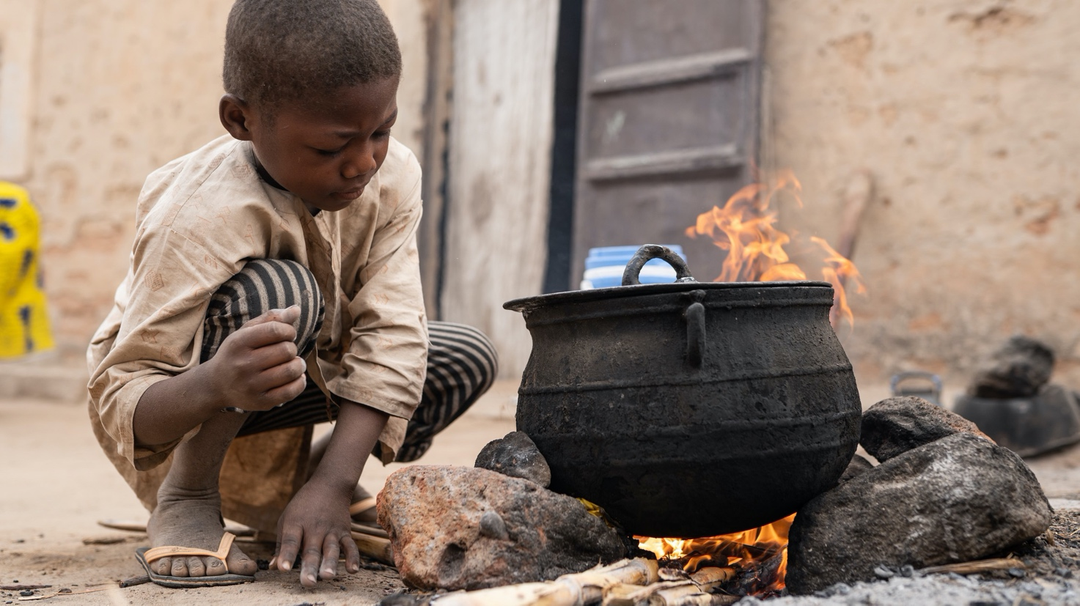

10

DOS and DON’TS
Below are some dos and don’ts on language when talking about COVID-19:

  - DO talk about the facts related to the new coronavirus disease (COVID-19).
  - DO talk about“people who have COVID-19”, “people who are being treated for COVID-19”, “people who are recovering from COVID-19” or
“people who died from COVID-19”.
  - DO talk about“people who may have COVID-19” or “people who are symptomatic for COVID-19”.
  - DO speak accurately about the risk from COVID-19, based on scientific data and latest official health advice.
  - DO talk positively and emphasize the effectiveness of prevention and treatment measures. For most people, this is a disease they
can overcome. There are simple steps we can all take to keep ourselves, our loved ones, and the most vulnerable safe.
  - DO emphasize the effectiveness of adopting protective measures to prevent acquiring COVID-19, as well as early screening, testing and treatment.

- Don’t attach locations or ethnicity to the disease, such as “Wuhan Virus” or “Chinese Virus”.
- Don’t refer to people with the disease as
“COVID-19 cases” or “victims” or “suspected cases”.
- DO talk about people“acquiring” or “contracting” COVID-19.
- Don’t talk about people “transmitting COVID-19”, “infecting others”, or “spreading the virus”, as it implies intentional transmission and assigns blame.
- Don’t repeat or share unconfirmed rumours, and avoid using hyperbolic language designed to generate fear like “plague”, “apocalypse” etc.
- Don’t emphasize or dwell on the negative, or messages of threat.

“Social Stigma Associated with COVID-19”. IFRC, WHO, UNICEF, 2020.2

Provide hope and spiritual support

A“COVID culture of care”: Promote respect and spiritual well-being towards
  - Religious leaders can provide mental, social, and spiritual support to their faith communities at
a time when people are going through a lot of uncertainty, fear, loss, and isolation. Religious leaders can promote positivity and hope to counter these negative emotions.
  - Continuation of religious practices, drawing on shared beliefs, and being a community can help with coping and building resilience to trauma and
mental stress. Religious leaders need to respond to the emotional needs of their congregation by
providing opportunities for online collective prayer, reflection and meditation.
  - During isolation, communities of faith can find creative ways to continue community service and enhance support networks, while complying with
health regulations on handwashing and physical distancing.

- Religious leaders need to think of the needs of their entire community, but must pay special attention to the vulnerable groups. They can mobilize
resources from the community and beyond, and volunteers from the faith community can reach the vulnerable and at-risk population with the help of their networks, such as youth groups and women’s networks.
When the sudden spread of Ebola started in Sierra Leone, the religious leaders were able to share messages through community radio. The Kenema Christian Council and the Council of Imams spoke with unity to bring attention to the sudden spread of the virus.3

11

COMMUNICATING TO END MISINFORMATION, DISCRIMINATION AND TO INSTILL HOPE

Encourage and engage people to support each other
  - Recruit and mobilize communities of faith, as well as volunteers, to work at all levels; local, national and international.
  - Help communities identify and reach out to people who are most vulnerable or may need special support.
  - Engage children and youth to share accurate information with their peers and families and avoid misinformation or stigma.
  - Women faith leaders can reach families through their networks, especially at a time when regular religious gatherings are prohibited.
  - Engage marginalized groups as agents of change, and encourage positive behavior for all ethnicities and towards differently-abled people.

Promote collaboration and support within and among faith communities
- Help to promote joint action across religions and denominations and help promote solidarity with individuals from marginalized groups.
- Leaders of different faiths can partner to share their learning about leading during the pandemic,
positive stories, and ideas for how to work with each other.
- Religious leaders can be under a lot of pressure during emergencies. They will need to take care of their own spiritual and mental health so they can
continue to help others.

Religious leaders can play a key role in dispelling misinformation and rumours.
Interfaith Call to Action: The world’s religious and spiritual traditions share common values that have resonated across the globe amid the COVID-19 pandemic. These values are uniting humanity, from the most remote village and grassroots communities to senior-most leaders. Each spiritual tradition upholds the inherent dignity and value of every person. In a time dominated by confusion and fear, the diverse faith traditions call all people to care deeply for each other by promoting peace, hope and solidarity within and beyond their communities.”

For information:
https://rfp.org/an-interfaith-call-to-action/
By: Anindito Mukherjee, New Delhi
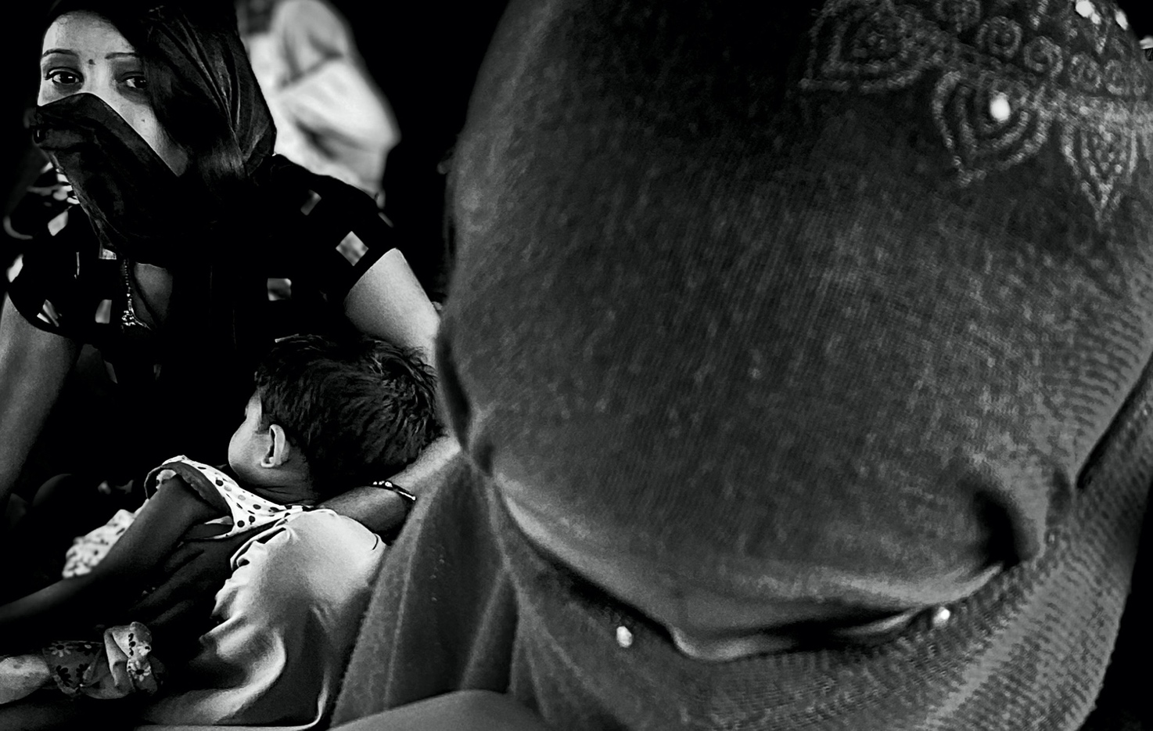

12

RELEVANT
RELIGIOUS TEACHINGS
Here are religious teachings and examples that help people with their spiritual and mental health during the pandemic:

Buddhism
  - In Buddhism, the Avatamsaka Sutra, Ch. 40 says, “When the mind is impartial towards all living beings, one can accomplish full and perfect Great
Compassion. By using the Mind of Great Compassion to accord with living beings, one perfects the making of offerings to the Thus Come Ones.”

Islam
  - “The believers are but a single brotherhood […]” (Qur’an 49:10).
  - “It is obvious that you cannot call yourself a believer if you do not help others, especially those who are poor and unable to go to the hospital
for healthcare; you cannot value and save lives without assisting those who are unable to go to the hospital. God said, ‘[…] help you one another in righteousness and piety, but help you not one another in sin and rancour […]’” (Qur’an 5:2)
  - “And We will surely test you with something of fear and hunger and a loss of wealth and lives and fruits, but give good tidings to the patient” (Quran, 2:155,
Sahih International)

Christianity
  - “Make sick people well again. Cause dead people to become alive again. If people have a bad illness of the skin, make them well again. Send bad spirits
out of people to leave them. God has been very kind to you, so you should be kind to other people.” (Matthew, 10:8)
  - “When there are threats, we want to identify where they came from – that is a natural response.
But our thoughts about the dangers should not make us think badly about those who are different… We should not exclude anyone or
treat anyone differently. This is against our beliefs and teachings. In most affected countries, people are getting the coronavirus from people around them. It is not spreading from people who have come from outside the area. To treat people badly and with prejudice is against our human right for respect. And it is against God’s will. Our experience in dealing with HIV and Ebola showed us this, and these attitudes make the spread of a disease around the world worse.” (Dr Manoj Kurian and Dr Mwai Makoka, World Council of Churches3)
Hinduism
- Swami Vivekananda, a famous Hindu Monk, said this at the World Parliament in 1893: “Do not stand on a high pedestal and take five cents in your hand and
say, “Here, my poor man”, but be grateful that the poor man is there, so by making a gift to him you are able to help yourself. It is not the receiver that is blessed, but it is the giver. Be thankful that you are allowed to exercize your power of benevolence and mercy in the world, and thus become pure and perfect.”

Judaism
- The Talmud (Shavuot 39a) says, “All Jews are responsible for each other.”
- When people are sick or in danger, it is important still to communicate together. For the Jewish community this has always been very important.
If you cannot visit somebody, then modern ways to communicate are very important. A hundred and fifty years ago, Rabbi Israel Meir Kagan, whom people also called Chafetz Chaim, said that it is a religious duty to communicate with your family. During war-time it is like “pikuah nefesh”, which means to save life. Talking with your family like this
may only help them psychologically, but that that is still good. (Mahaneh Yisrael, 35 1, 48)

Sikhism
- Akal Takht is the highest Sikh authority. On 23 March 2020, it wrote to all Sikhs around the world about coronavirus. It told all Sikhs to help people
in their regions. They must provide food as Guru Nanak’s free kitchen requires. They should send medicines and other necessities to those who need them. Sikhs should also follow the instructions of the government and health department in their own countries about staying apart from others.

COMMUNICATING TO END MISINFORMATION, DISCRIMINATION AND TO INSTILL HOPE
13

COMMUNICATING TO END MISINFORMATION, DISCRIMINATION AND TO INSTILL HOPE

Zoroastrian
  - In the Zoroastrian religion, Zoroaster said, “Doing good to others is not a duty. It is a joy, for it increases your own health and happiness.”

Jainism
  - In Jainism, the Bhagavati Aradhana (780) says, “Just as you do not like misery, in the same way others also do not like it. Knowing this, you should do unto
them what you want them to do unto you.”

Baha’i Faith
- “Whatever competent physicians or surgeons prescribe for a patient should be accepted and complied with, provided that they are adorned with
the ornament of justice. If they were to be endued with divine understanding, that would certainly be preferable and more desirable.” (Bahá’u’lláh, Bahá’i tradition, translated from the Persian)

Multi-religious
- “All faiths compel us to protect lives and to acknowledge and honour the divine breath within each person and in one another.” Religions for Peace

A devotee prays in isolation at a Buddhist temple in India By Ashutosh Sharma

Photo credits (clockwise):

A devotee at the gate of a Sikh Gurudwara wearing a face mask and gloves, Ghaziabad, India
By Ashutosh Sharma

A devotee at a temple in India wearing a face mask . Ghaziabad, India
By Ashutosh Sharma

On 3 April 2020, a nurse takes a girl’s temperature at a Primary Health Care Centre in Beirut, Lebanon.
By UNICEF/Fouad Choufany

14

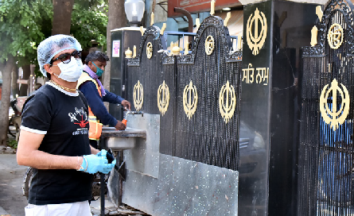
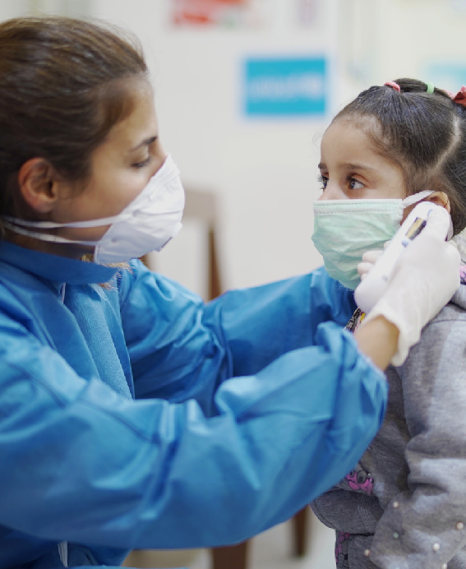
COMMUNICATING TO END MISINFORMATION, DISCRIMINATION AND TO INSTILL HOPE
15

IDEAS FOR DIALOGUE AND ACTION

For religious leaders, your position and the role of faith becomes even more central in these troubled times. People will have a lot of questions, and there may not always be easy answers. The documents in the Multi-Faith Action for COVID-19 initiative provide more guidance on all of these topics and you can consult them for further information. As a starting place alongside your adaptations to religious gatherings and practice, you can also consider the following:

Who can you partner with to spread the word? Who can you work with to educate your community and provide the needed support?

How can you instil faith, trust, and cooperation? As community leaders, how could you use your trusted position and influence

Share an example of collaboration with local authorities for adapting your religious gatherings and practices. Share
your written example by email (no more than 50 words) and a photo (150 pixels) if you have one.

info@rfp.org c4dunicef@gmail.com

CONNECT BACK WITH US!
followers and the wider community to cooperate with the national health authorities and guidelines? What kind of immediate help from
within the community could be arranged to alleviate the economic and mental stress resulting from loss of income? What can you do in
an inter-faith network to influence the wider community?

How can the community help themselves? What are the available community assets and strengths that can be used to unite and to protect each other? How does the community want to adapt the way it holds gatherings? In gatherings without a religious leader present, how are community members maintaining healthy practices, while also continuing to meet and share fellowship with each other? How can we share ideas?

ADDITIONAL RESOURCES

  - EMPACT Africa, “Stigma-Free Faith Communities: A Faith Leader’s Guide to Ending the Stigma of HIV and AIDS” http://www.empactstigmafree.org/GuidebookIntro. htm
(see “Best Practices for Ending Stigma” on page 14). See also EMPACT Africa, “Faith and Stigma on the Fast Track: A Framework for Taking Action” http://www.empactstigmafree.org/FastTrackIntro. htm
  - Religions for Peace, “Combating HIV and AIDS Related Stigma, Denial and Discrimination: A Training Guide for Religious Leaders” https://rfp.org/wp-content/uploads/2017/08/ Combating-HIV-and-AIDS-Related-Stigma-Denial- and-Discrimination.pdf
  - The World Council of Churches has a list of experts that you can contact for more advice: https://www.oikoumene.org/en/resources/ documents/covid-19/resources
  - The United Nations Office on Genocide Prevention and the Responsibility to Protect, in conjunction with International Dialogue Center (KAICIID) and the World Council of Churches (WCC), “Plan of Action for Religious Leaders/Actors from the Asia- Pacific Region to Prevent Incitement to Violence that could Lead to Atrocity Crimes”. https://www.un.org/en/genocideprevention/ documents/Plan%20of%20Action%20for%20 religious%20leaders_AsiaPacific.pdf
  - The Tony Blair Institute for Global Change, “Covid-19: A Guide for Governments Working with Religious Leaders to Support Public Health
Measures”, including information about countering misinformation and examples of good practice: https://institute.global/policy/covid-19-and-need- governments-work-religious-leaders

Endnotes
- https://www.episcopalrelief.org/what-we-do/ us-disaster-program/faith-based-response-to- epidemics/
- IFRC, WHO, UNICEF, “Social Stigma Associated with COVID-19, (2020).
- Christian Aid, CAFOD, Tearfund, Islamic Relief Worldwide, “Keeping the Faith: The Role of Faith Leaders in the Ebola Response,” Featherstone, 2015, https://jliflc.com/resources/keeping-the-faith-the- role-of-faith-leaders-in-the-ebola-response-full- report/. Page 28
- https://www.oikoumene.org/en/resources/ resources/documents/overcoming-the-covid-19- pandemic-with-faith-communities-some-guidance- for-churches/

COMMUNICATING TO END MISINFORMATION, DISCRIMINATION AND TO INSTILL HOPE

16

COMMUNICATING TO END MISINFORMATION, DISCRIMINATION AND TO INSTILL HOPE

JOINT CALL TO ACTION
for the Faith-in-Action COVID-19 Initiative by the UNICEF Executive Director, Henrietta Fore, and 13 of Religions for Peace’s Senior-most leaders representing diverse religious traditions:

  - Religious practices: Adapt faith gatherings, rituals, and services to ensure the safety of worshippers and develop alternative pastoral approaches.
  - Hygiene: Promote a heightened focus on handwashing, hygiene and sanitation.
  - Active listening: Listen to the experiences, needs and hopes of children and families and provide support for inter-generational dialogue.
  - Advocacy: Promote the inclusion of voices of faith and wider community engagement to inform local responses.
  - Communication and inclusion: Tackle misinformation, rumours, stigma and discrimination associated with the disease.
  - Active engagement: Engage networks of religious communities including faith-based women’s and youth organizations in collaboration with local governance structures to provide organized voluntary services.
  - Pastoral Care: Provide further spiritual and emotional care and support to bring comfort and hope for parents, children, and the elderly.
  - Parenting: Promote positive age and gender-specific parenting guidance and support to families, particularly the most vulnerable and the hardest to reach.
  - Youth engagement: Practice youth-friendly communication and engagement including more systematic use of technology and social media during periods of physical distancing and beyond.
  - Recovery: Provide support for recovery of social services.

Signatories:
Ms. Henrietta Fore, UNICEF Executive Director
Dr. Vinu Aram, Director, Shanti Ashram
Rev. Kosho Niwano, President-Designate, Rissho Kosei-Kai
H.E. Shaykh Abdallah bin Bayyah, President, Forum for Peace in Muslim Societies, Abu Dhabi
H.E. Metropolitan Emmanuel, Metropolitan of France, Ecumenical Patriarchate
Ms. Bani Dugal, Principal Representative to the UN, Bahá’í International Community
Mr. Homi Gandhi, President, Federation of Zoroastrian Associations of North America
The Most Rev. Antje Jackelen, Archbishop of Uppsala, Primate of Sweden, Church of Sweden
H.E. Sheikh Shaban Ramadhan Mubaje, Grand Mufti, Uganda
H.E. John Cardinal Onaiyekan, Archbishop Emeritus of Abuja, Nigeria
Ms. Aruna Oswal, Vice-President, World Jain Confederation
Grand-Father Dominique Rankin, Algonquin Hereditary Grand Chief
Chief Rabbi David Rosen, KSG CBE, International Director of Interreligious Affairs, American Jewish Committee
Bhai Sahib Mohinder Singh, OBE KSG, Chairman, Guru Nanak Nishkam Sewak Jatha https://rfp.org/launch-of-global-multi-religious-faith-in-action-covid-19-initiative/
17

COMMUNICATING TO END MISINFORMATION, DISCRIMINATION AND TO INSTILL HOPE

