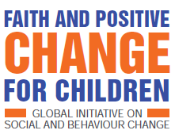

EARLY ADOPTERS’ WORKROCK
SOUTH SUDAN 7-11 OCTOBER 2019
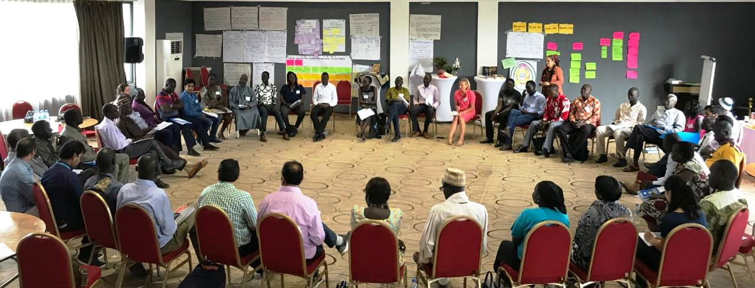
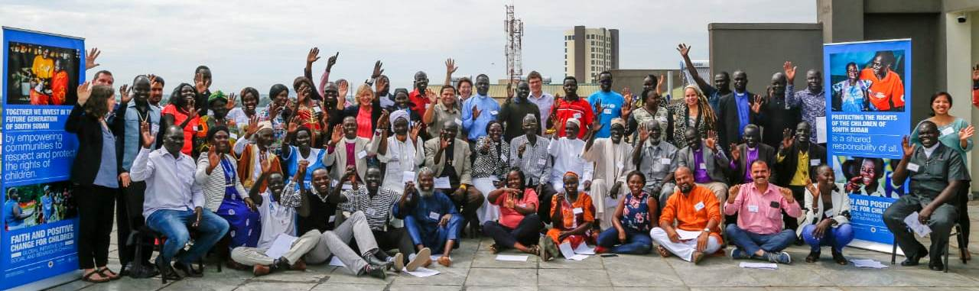
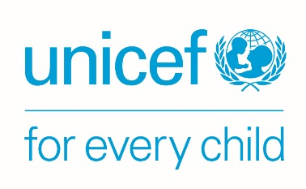
SUMMARY REPORT

THE FOUR-DAY WORKROCK PROCESS – FAITH FOR POSITIVE CHANGE FOR CHILDREN (FPCC)
Learning exercises combined with mind and heart dialogue/ breaking barriers activities to embed commitment

DAYS 1-2: Developing a South Sudan FPCC ‘journey of change’ - building a wall chart
Case study analysis

- Buzz group learning

- Check-in on WorkRock outcomes and process
Childhood roadmap
- Mapping childhood journey
- Children’s voice: feedback formative research
- Group discussion: perpetuating the cycle

- Fruit salad energiser

- Personal story and faith reflection

Living out partnership – an enabling environment

- Changing hats: group exploration of partner roles
- Partnership principles: brainstorming and bean ranking

- Listening well skit

- Power walk and laying down titles

Most Significant Change stories

- Group stories: behavioural outcomes and results for children
- Selected stories: qualities, approaches and strategies
Scene-setting
- Timeline of the FPCC initiative

- Check-in on WorkRock outcomes and process
Faith and Childhood
- First memories of faith and childhood
- Sacred text reflection
- Faith symbol reflection: laying down burdens

- Keeping the balloons up icebreaker

DAY 3: Modelled and embedded in hearts a new way of working
The journey of change for child marriage - example
- Group development of the journey of change
- World café sharing of the journeys

- Listening head, heart and feet: personal change stories

Drivers of child marriage – example
- Drama demonstrating evidence about drivers
- Group review of link to South Sudan context
- Prioritisation – bean ranking
Journey of change reflection
- FPCC global ‘theory of change’ presentation
- Paired reflection on South Sudan and global journeys of change

- Check-in on WorkRock outcomes and process
- String game

DAY 4: Planning for a new way of working in South Sudan
- Jungle ice-breaker symbolising unity
- stories: listening to emotions and drivers

WorkRock evaluation and wrap-up
- Individual or paired written evaluation
- Plenary ideas for taking forward national partnership

- Pass the microphone reflection on learning

- Defenders balloon game
- Personal commitments laid at faith symbol

- Secret in a box exercise

Action planning

- Regional group planning
- Organisational/ group planning
Personal and collective commitments

- Collective commitment examples and action

- Check-in on WorkRock outcomes and process

INTRODUCTION
The Faith for Positive Change for Children initiative
The ‘Faith for Positive Change for Children’ (FPCC) global initiative aims to enable UNICEF and faith-based actors to work together in a more sustainable, systemic, integrated and scalable way to impact children’s lives. UNICEF has a long history of active engagement with local faith actors. Its 2014 mapping showed that its approach across 150 countries was mainly ad-hoc, short-term and message-based. It was instrumentalising faith groups, rather than working collaboratively to address the complexity of social and behaviour change. Its Communications for Development (C4D) section therefore teamed up with the ‘Joint Learning Initiative on Faith and Local Communities’ and ‘Religions for Peace’ on this initiative. In 2018, they drew together the global evidence base to show what really works, reviewed toolkits, held a UNICEF and faith partner workshop in Bangkok, documented case-studies of UNICEF’s existing work in this area, co-created a theory of change for the initiative, and set up an advisory group of 20 partner organisations and web platform to share resources. Since then, the initiative has developed draft guidance and a package of resources to support roll-out.
The WorkRock purpose and approach
UNICEF South Sudan was the first of five early adopter countries in Africa (with Malawi, Liberia, Cameroon and Niger) to host this ‘WorkRock’ – a term that shows that this is not ‘business as usual’ but about figuring out a new way of working together, based on strong foundations in evidence. With the help of the South Sudan Council of Churches and Islamic Council, it brought together 65 faith leaders and organisations, government officers and UNICEF staff (annex 4) to achieve:
a shared ownership of the initiative and a new way to work together
understanding and heart change in how to work
barriers broken down between and within faith actors and UNICEF
ideas and plans to take forward the initiative

The WorkRock approach was participatory – not based on presentations from the front but on capacity-sharing among participants with exercises that engaged minds, hearts and beliefs. It also fed in evidence from the global initiative and social and behaviour science. Discussions and exercises took place in different group sizes and compositions, including: ‘change groups’ (mixed groups named by the participants); ‘buzz’ groups of three people for short brainstorms; and paired and individual work.
Before the WorkRock, participants carried out ‘formative research’ (consultation) with groups of 6-10 children (15-18 years old), young people (19-24) and adults (25-45) from communities in different regions, supported by UNICEF’s ten field offices. They used a participatory exercise to explore local priority issues facing children, especially in relation to harmful practices like child marriage, and who influences decision-making. The process aimed to model good practice, bring the voices of children and young people to the WorkRock, understand local barriers and give everyone a shared experience to contribute to the WorkRock as equals. Those that were able in the limited time, also prepared a story of ‘most significant change’ to share their learning about what is working effectively.
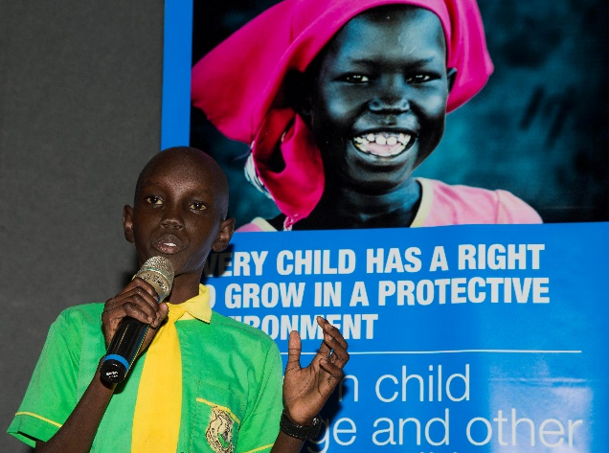
The WorkRock process
An opening ceremony launched the initiative in South Sudan with high level leaders from government, faith groups, UNICEF and embassies. Children dramatically presented their concerns in a radio-style broadcast (photo right), poem and dance, emphasising: “Child protection is a collective responsibility of all stakeholders to protect and empower South Sudanese children to realise their academic dreams and aspirations” (Priscilla Nyandong)
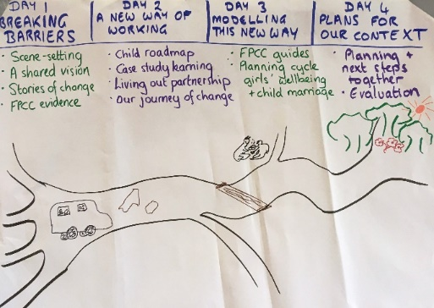
The Vice President, H.E Professor James Wani Igga, as guest of honour, delivered the keynote speech: “While Africans value the importance of culture and tradition, practices that once protected them now put them at special risk. Culture and tradition should not be used to violate the rights of children.”
The WorkRock itself took place over four days – envisaged as a bus trip together (photo left). The detailed process itself is summarised above (p0) and in the WorkRock agenda (annex 2).
- DAYS 1 AND 2: DEVELOPING A SOUTH SUDAN FPCC JOURNEY OF CHANGE
The first two days focused on sharing participants’ knowledge and experience, strengthened with external learning from the initiative, to develop a ‘journey of change’ to show how faith groups can work with others most effectively to change attitudes and behaviour to bring lasting and positive results for children.
During the two days, the facilitators added the learning to a wall chart structured in line with the FPCC global theory of change. This meant that participants could own their journey of change and compare it with the global one, rather than have it presented. In line with FPCC evidence, the sessions combined knowledge-sharing with ‘mind and heart dialogue’ to connect with emotions and beliefs, thus embedding the learning.
A1) Faith and childhood
After an ice-breaker and ‘who’s in the room’ exercise so participants could begin to get to know each other, the first session immediately therefore took everyone into faith and childhood. The aim was to develop a shared faith or ethics driven sense of responsibility to protect and support children. Individually, each reflected on their first memory of faith, how it impacted them as a child and how it made them feel. They talked this over in buzz groups and then some people shared their experience in plenary, highlighting the positive impact that faith has on children, but also the negative. Each reflected on their sacred or inspirational texts to draw out attitudes and behaviours we are meant to show to children and compare that to their own experiences.
For some, this opened up knowledge about the sacred texts of which they had been unaware (annex 3), such as Bible passages about not frustrating your children (Ephesians 4:4)) or Qur’anic teaching about breastfeeding (Surah Al-Baqarah 2:233). It highlighted a shared vision and motivation to teach children by what you say, do and how you behave; and to protect them. It also surfaced issues about sacred text interpretation, such as understanding the Biblical reference to a ‘rod’ (Proverbs 13:24) to discipline children in its context: the shepherd used the rod to guide and protect – not to beat. The session ended by focusing on a relevant faith symbol for each person (from separate tables of Moslem, Christian and other symbols). Each reflected on the discussion and then laid down a rock to represent any burdens or hurts experienced in the past or that they were bringing to the WorkRock.
“I saw how both religions are trying to work to remove evil and help children in this nation. Our mandate to care for children comes from our faith.”
(participant)
A2) Scene-setting and working together
The UNICEF global C4D advisor leading the initiative mapped the global timeline so everyone could see how the country WorkRock fitted. A ‘power walk’ exercise enabled everyone to reflect on who is most left out in our communities but also in our own WorkRock. Each person was given a character in South Sudan and took a step forward when any of a series of statements applied to them – such as whether they were safe from violence. Some characters such as government officials, UNICEF and NGO staff and faith leaders moved far ahead; while others such as women in rural areas, children with disability or girls were left far behind. Participants drew out guidelines to create a safe space for everyone to take part. They wrote down their titles and roles and laid them down to symbolise everyone participating equally and making their voices heard. Each shared any questions or concerns about the week and their hopes in relation to the WorkRock outcomes.
A3) Most significant change stories – developing our journey of change
Before dividing into their mixed ‘change groups’, participants watched a skit of bad and good listening. This highlighted the importance of body language and of affirming what you hear. Participants then shared stories of how they had seen faith influence people’s attitudes and behaviour to bring positive change for children. The groups documented the behavioural changes achieved and for whom, and the resulting impact for children. Their stories covered diverse issues and showed, for example: parents’ changed attitudes towards vaccinations; religious and community leaders’ and parents’ changed behaviour on child marriage; changed attitudes and practices to facial cutting and teeth removal for boys; improved parenting practices to create a more caring and safer environment; empowered communities taking action through networks; and increased support from churches for street connected children. These behavioural changes led to more girls in school; children being safer; and increased health and healing from trauma.
Each group chose one story to feed back in plenary that showed most impact on attitudes and behaviour. As they told their chosen story, participants drew out together how change had happened – the approaches and ways of relating that had brought and sustained positive change. Their stories highlighted that the qualities that faith groups and communities demonstrate are as key to lasting change as the approaches, strategies and interventions, summarised below:
“It was a great day. I learned a lot about how change happens.”
“Interactive and paced sessions that facilitate self-learning.”
(participant feedback on the day)

Qualities | Foundational approaches | Core strategies | Interventions
self-reliance | exploring culture through Qur’an or Bible and technical information | role modelling | outreach
good relationships |  | good partnerships with faith groups, communities, NGOs, government | counselling
care for the whole child |  |  | child and youth groups
inclusion | mobilising wider faith groups and communities |  | extended family meetings
courage |  | advocacy and promoting awareness of laws
openness to engage on sensitive issues |  |  | rituals and rites
 |  |  | campaigns
A4) Case study analysis – developing our journey of change
Participants also discussed case studies to validate and extend their own experience through external learning – two were of UNICEF’s work with faith groups and one from a local faith-based organisation. Their most important learnings from these were the importance of:
- Dialogue to change people’s mindsets: using sacred texts
- Collective efforts of faith groups with communities: involving all stakeholders to integrate support
- Community ownership, using their own resources: not waiting for outsiders or over-reliance on funding
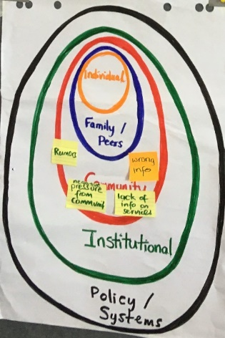
- Influencing government to scale up the work: engaging leaders and key influencers, changing laws
A5) Checking in on our emerging journey of change
The UNICEF C4D global adviser explained the structure of the journey of change. The destination is the impact on people’s attitudes and behaviour that bring positive results for children. The journey must tackle challenges at different levels (photo right) that might prevent reaching the destination. A story of a nurse in Ethiopia illustrated this: the nurse educated people against Female Genital Mutilation (FGM) but sent her own four daughters to be cut in a neighbouring country. The story highlights the importance of not just imparting knowledge, but changing societal fears and beliefs (such as that men will not marry uncut girls) at all levels: individual; family and peers; community; institutional; and policy. She also introduced the importance of working in our journey of change at intra-faith level (in our own faith group); inter-faith (between different religions); and faith group with the wider community. As participants developed the journey of change together, they explored how they could operate at each level.
A6) Child roadmap – internalising our responsibility
Following the discussion about the importance of changing attitudes and beliefs, not only knowledge, this next exercise reflected on how this applies to individuals, their families, communities and faith institutions.
Personal stories: Two participants shared their own childhood stories: one about a girl’s struggle to go to school because of her family’s opposition, instead using her for domestic work and guarding the cattle; and one of a boy fleeing the conflict to walk for a year to Ethiopia and the massive challenges he faced that enable him now to help others who have suffered trauma. Their vulnerability and courage helped break barriers and highlighted their resilience as well as external positive and negative influences on their journeys.
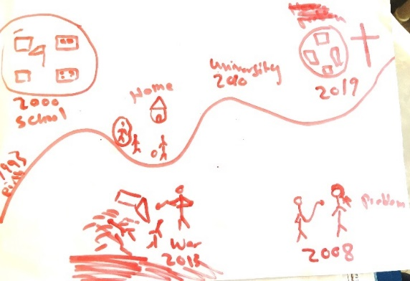
Childhood map: In pairs, participants mapped the ups and downs of their childhood (photo left), discussing influences, including faith.
Formative research feedback: The WorkRock then reflected on the findings from the formative research and the learning about the issues that children face today. Participants put on hat to represent a girl-child or boy-child. They fed back in the children’s own words what they had said, especially in relation to harmful practices and who controls the decisions that are taken. Girls spoke about how they are valued in society: they are seen as property or income and married off early; prevented from attending school by domestic and other work; have no inheritance; and are given as compensation in exchange for murder. Fathers and uncles are the greatest influences on school and work practices, as well as mothers. Chiefs, traditional leaders and wider tribal beliefs have most influence on girl compensation, as well as policy makers. Boys spoke of conscription into the armed forces; beatings if they do not look after the cattle; not being able to marry without a dowry of cattle; and being expected to take on certain roles and not others, like cooking. Mothers and sisters most influence their roles at home; while fathers and uncles take decisions on the other issues; and the bride’s family and community on dowry.
Continuing the cycle of abuse: Change groups explored the link between what the children face today and their childhood maps, highlighting how our own behaviour perpetuates children’s suffering – sometimes actively supporting harmful practices or keeping silent and not intervening. They discussed misuse of religious teachings to encourage child marriage, polygamy and child violence; cultural attitudes to boys and girls, including emotional suppression of boys and expectations of girls’ behaviour and girl/ boy roles; and harmful parenting practices, such as too little time spent with children and not involving them in decision-making.
A7) Living out partnership
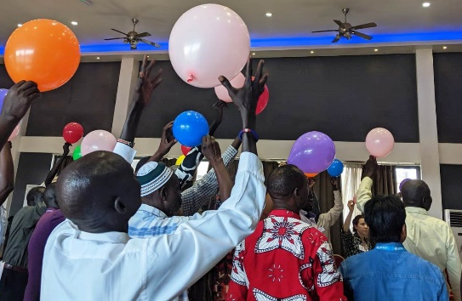
The next section focused on how to create an enabling environment to work together to achieve the journey of change for children.
Balloon game: Participants each took the challenge (photo right) to keep balloons up in the air for 45 seconds, but only tapping each one twice. After counting the number left, they discussed how to improve and tried again. The exercise showed that strategy, teamwork, practice and making room for ‘smaller’ people are critical to protect children.
Changing hats: Back in their ‘change groups’ each person then took on the role of someone different to them in the partnership to support children and shared what they can contribute – summarised in the table below:

Partner | Role
Mothers and fathers | sending children to school and changing harmful community practices
Religious leaders | conflict management, coordination, providing a safe space for dialogue, encouraging positive behaviour through scripture, providing emotional support
Community leaders | mobilising others, promoting customary laws to protect girls and advocacy
Government | providing services and forming and enforcing laws
NGOs | helping to hold government accountable
UNICEF | bringing people together for advocacy, in monitoring and in technical support
Media | encouraging good practices in parents and awareness of harmful practices
In the plenary discussion following this exercise, the group noted that the role of boys and girls themselves were hardly mentioned – and then never in relation to decision-making and influence on their own lives. Facilitators shared the evidence that child participation is one of the greatest evidenced influences on effective and lasting change. For example, Mothers Union’s Listening, Observing and Acting process (MULOA) involved over 250,000 in 40 countries in listening to people through interactive activities. They used to provide many services for children but when they really listened to them, it changed everything. For example, in one after-school club in South Africa, after only a two-hour participatory session, they learned that the children were suffering terrible sexual abuse in the schools. The women therefore began visiting the families and brought all the agencies in the local community together – police, government health and social workers, teachers etc – to tackle the abuse.
“We are not listening to the kids and respecting them. When we opened (the WorkRock), all of us were crying listening to the children…. We as elders with local religions, Islamic or Christian…we can do something... they are human beings. They have taught me something that went out of my mind.” (participant)
Principles of partnership: Based on the discussion, everyone reflected on the principles that would make this partnership effective and enable everyone to contribute their part. After brainstorming they used a ‘bean ranking’ exercise to prioritise the most important. Everyone took ten beans each and scored the principles individually before discussing the ranking together and moving the beans around until they reached a consensus in the group (photo below). Groups fed back their top three principles. The facilitators then drew together the results from each group to form one list to add to their journey of change chart:
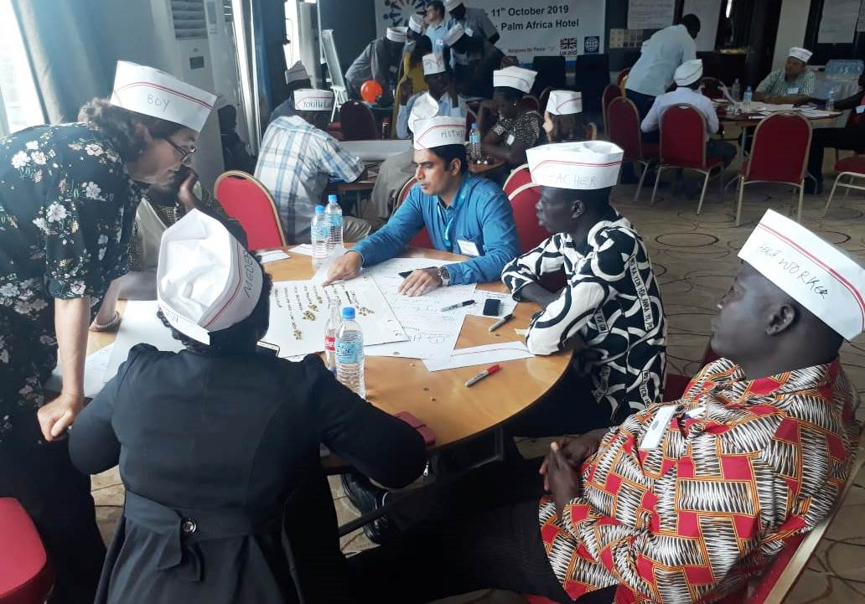
- Shared vision: clear priorities to tackle together
- Team-work: effective coordination/ communication
- Accountability: honesty with the children, each
other and God
- Trust: good relationships, mutual respect and
shared decision-making
- Commitment: joint responsibility, including using
our own resources
- Safe space: security, freedom to express oneself
A8) Journey of Change reflection
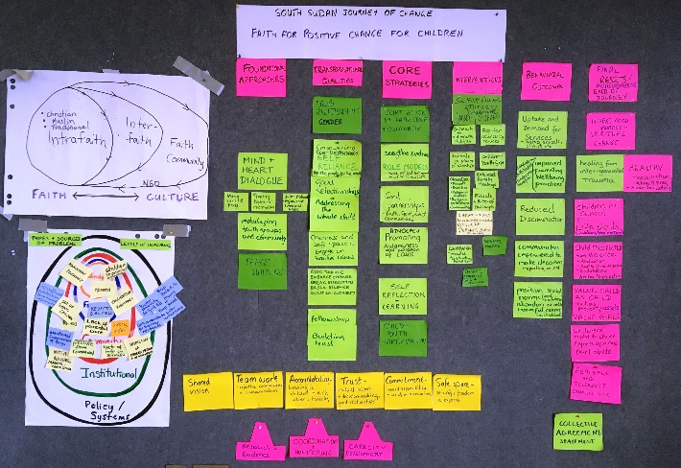
The WorkRock drew together all the work carried out by participants to develop their journey of change on the following morning of day 3. In pairs, everyone reviewed the wall chart they had developed together to see if it captured their learning and whether there was anything missing or wrong. They also compared it to the global FPCC theory of change, noting areas they could feed into the global learning as well as anything that challenged their own journey of change. They pointed out that the global theory of change needed to include the role of NGOs in influencing and research; to capture sacred text reflection and study under mechanisms; and to include building relationships of trust. On the South Sudan journey of change, participants agreed to make the titles for each section clearer: changing platforms/ mechanisms to ‘interventions’; and results to ‘final results/ achievements’. They added ‘peacebuilding’ as a foundational approach in South Sudan as faith groups are core to the process and: “we can’t do any of it without doing the main agenda of peacebuilding”. They also added joint action by faith groups and communities to their core strategies. This includes getting communities to make collective commitments to action – a learning from one of their stories of change and evidenced in social and behaviour science as a way to achieve wider community impact. They made child/ youth participation a core strategy and gender more explicit as part of the transformational qualities, capturing work with women of faith under interventions. The resulting South Sudan FPCC journey of change wall chart (photo right) is documented in annex 1 of this report.
C) DAY 3: MODELLED AND EMBEDDED THIS NEW WAY – CHILD MARRIAGE
B1) Working together - the string game
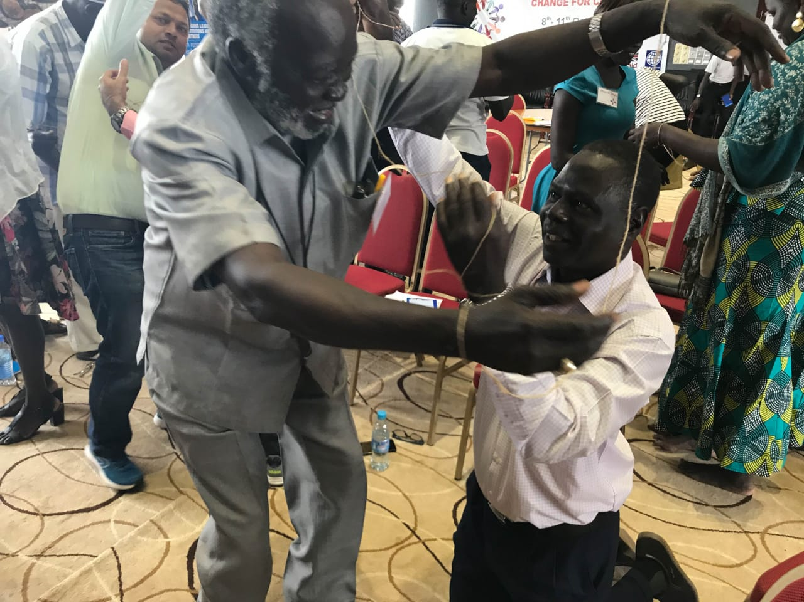
After finalising the journey of change, the aim of day 3 was to apply that process of achieving social and behaviour change to a specific issue. Child marriage was chosen as an area requiring long-term and integrated efforts to make an impact and where faith groups can have a positive or negative influence. As a reminder of how those directly involved with the issues at community level are best placed to solve them together, everyone divided into pairs, each with a string tied around the wrists and threaded through their partner’s. They worked together until they extricated themselves (photo left) – also learning from those who solved it early on.
B2) Surfacing the drivers of child marriage
UNICEF C4D staff performed a drama based on a real story in South Sudan of child marriage. Participants reflected on the power of drama, sharing their own experiences of using it and then drew out from it their learning about the drivers of child marriage – the reasons behind it – including:
- The pastor’s fear of going against the culture – customary law is more important – and fear of conflict
- The mother’s fear of losing status
- Lack of voice of the women and girls in decision-making – girls are seen as ‘property’
- Peer influence; ‘booking’ practices are accepted as normal
- Misinterpretation of scriptures; lack of understanding of the mandate to protect children; rites of passage
- Financial gain for the bride’s family and need to have cows for the sons to marry; the pastor’s fear that people will not come to his church, thus reducing his income
- Lack of knowledge among lawmakers and community about the effects of child marriage
In their ‘change groups’, participants then analysed all these emerging drivers and prioritised the three most important – acknowledging that these could vary across the different tribal groups in South Sudan. One group used the ‘bean ranking’ exercise again so everyone could participate equally.
B3) The journey of change for child marriage
In three regional groups, participants developed a journey of change for child marriage, identifying the behavioural outcomes that were needed in relation to the priority drivers/ causes. For example parents understanding that educated girls bring more wealth and that there are other sources of income; parents changing their practice of giving girls to marriage at an early age; communities understanding the effects of child marriage and taking action to stop them; and girls empowered to know their rights and be self-reliant. The groups then analysed how they could achieve those changes through the foundational approaches, core strategies and interventions. Some examples of their analysis are below:

Foundational approaches | Core strategies | Interventions
mind and heart dialogue using sacred texts; sharing technical information (CRC, child act etc); internal reflection (childhood journey, power walk, testimonies) | role modelling | in assemblies, peer to peer
 | child/ youth participation | child/ youth groups
 | promoting awareness of the law and the negative effects of child marriage | Sunday schools, madrasas, Quranic schools, services, masses, scriptural studies
mobilising wider faith groups and communities: intra and inter-faith/ and wider community | joint action by faith and community groups | outreach to vulnerable children
 |  | extended family meetings; community consultations; events, involving media
 | collective commitments
The groups fed back their journeys of change in a ‘World Café’ style, leaving one person to present their analysis as the rest of the group circulated round the other two stations.
B4) Listening to the facts, heart and motivations
The last session of the day involved another heart and mind exercise to practise listening to the deeper emotions and drivers behind what people say. In pairs, everyone shared one personal story of a positive change they had made in their lives, whether in work, family, faith or wherever. They shared that story while the other person listened for the head (to the facts); for the heart (to the feelings); and for the feet (what drove people to make the change or held them back). The day closed with a group review and prayer.
C) DAY 4: PLANS FOR A NEW WAY OF WORKING IN SOUTH SUDAN
The final day focused on how everyone could take forward practically their new way of working together to benefit the children of South Sudan. Everyone reflected on the religious symbols, recalling sacred or inspirational texts that would motivate us to move forward. Participants recapped the South Sudan FPCC journey of change and their child marriage example. They shared stories of how putting the foundational approaches into practice led to transformation in the community without any externally funded projects. All the mind and heart dialogue exercises used in the WorkRock are ones that can be used at community level to change mindsets and mobilise wider groups. Facilitators therefore asked everyone to stand along a ‘line of agreement’ for each of the exercises to show how confident they felt to use them in their own locations.
C1) Personal and collective commitments
Everyone divided into four groups to take part in the ‘Defenders’ balloon exercise, without knowing the other groups’ roles. Group 1 each tied a balloon around their ankle which they had to defend; group 2 chose one person from group 1 to protect; group 3 had to burst the balloons; and group 4 to observe. Those with balloons represented vulnerable children or women: they felt confused as they did not know who to trust and feared for their safety. Group 2 protectors found they were the same sort of people as the group 3 perpetrators of violence: mothers, fathers, religious leaders, chiefs, NGOs, UNICEF etc. The protectors felt responsibility but also frustration and confusion as they were pushed away and not trusted. The perpetrators were happy to win, but also felt the injustice of what they were doing. The observers represented those who keep silent without acting, such as parents who do not react to protect their children, who keep quiet. At the end of the exercise everyone disengaged from negative roles and declared together: “I want to be a child protector”.
Following this exercise, the group took a few minutes to reflect on the faith symbols and each wrote a personal commitment arising from the WorkRock. The UNICEF C4D regional advisor then gave some examples about how mind and heart dialogue can mobilise communities to make a collective agreement. Participants reflected on how this can help to break “the barrier of silence and publicly give a wake-up call so it can spread faster around the country”. As a visual image of this collective statement and to respond to the fact that day 4 was the international day of the girl child, each wrote a public commitment to the girl child on a paper and posed for a group photo to contribute to UNICEF’s advocacy communications for girls in South Sudan.
C2) Secret in a Box – who are the experts?
Before going into regional planning, the UNICEF C4D global advisor led an exercise to demonstrate that those within the communities are best placed to tackle their own issues. She called three ‘volunteers’ forward to represent someone who travelled internationally, another who travelled nationally and someone right inside the community. The first had to shake a box of ten objects and try to guess what was in it; the second could feel the objects but was blindfolded; and the third could open the box, take them out and explain what they were. The group then reflected on the lessons for UNICEF and NGOs in thinking they are the experts, when in reality they can provide support, but not know the situation inside a community. One of the participants gave an example of a school the community built and protected during the conflict while another, built by an NGO, was destroyed – when asked why they had protected the one school, they responded: “this is OUR school”.
“Those of us in the community, we are the ones who discover what is going on in the community and it is the level of the community that we can make change. We are the ones who know our own stories and the solution for us.”
(participant)

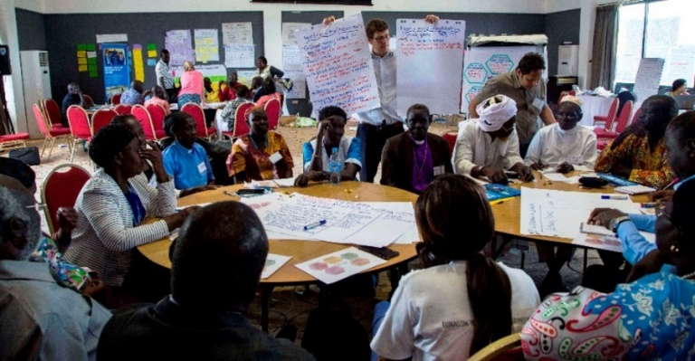
C3) Action planning
Three regional groups (photo right) followed a planning cycle to agree how they could share and take forward the initiative in their own locations. Each participant then planned what this meant for them at faith group or organisational level. The whole group discussed how to keep in touch and review progress, such as forming a national working group for FPCC. Some examples from their regional action plans are below:

- Getting the right people on board and building vision
Introducing the vision to a smaller group who can champion the initiative
Identifying key influences from church, mosque, women and youth groups, government, community leaders, chiefs, elders to reach commitment and assign roles
- Listening and learning
Sharing experiences using the ‘power walk’; story-telling; testimonies; and role play
Collect data on issues affecting children from the community
- Prioritisation and planning – developing a journey of change
Story-sharing on personal experiences; drama performances
Working on local priorities linked to the barriers to girls’ education: girl compensation; child marriage; early pregnancy; street children; orphans
- Putting into action – mind heart dialogue and mobilisation
Establish children’s story-telling groups in schools and worship places and link them with media, role models, authorities
Story-telling, discussions and fun days for children; Sunday awareness; radio talk shows; youth conference
- Checking on progress
Record the number of churches, mosques, women’s groups, schools etc involved
Photo evidence, stories, personal testimonies, attendance records and reports

D) WORKROCK LEARNING
This was the first of the early adopters’ WorkRocks and therefore critical for learning how to take forward the initiative in other countries, as well as for the impact within South Sudan. Throughout the week, the facilitating team from UNICEF global, regional and South Sudan; the Joint Learning Initiative for Faith and Local Communities and Religions for Peace met at the end of the day to review learning from the participants and from their own observations. Key lessons mainly focused on simplifying things more to make it easier for people to put the learning and activities into practice:
- Pre-WorkRock preparation: Make clear that the results can be messy; the important thing is to involve children (15-18), adolescents (19-24) and adults and get them talking to each other about real experiences – and prioritising. Stories do not need to be from funded projects and may be better if not.
- WorkRock framing: It is important to clarify beforehand that this is an engagement workshop – not a training – and that it will be important to support facilitators to develop the skills to roll out the process.
- Initiative resources: The redraft FPCC module on child marriage needs simplifying. A toolkit of exercises used in the WorkRock is needed to support participants as they use these activities in the roll-out.
- Opening ceremony: The launch event helped create an atmosphere of commitment and cooperation. The voice of the child communicating their real issues helped focus the WorkRock from the start.
- Sacred text interpretation: It is helpful to have ‘Religions for Peace’ to co-facilitate the sacred text reflection and to introduce them (or others who can act as scholars of sacred texts in relation to child rights) from the beginning, so everyone knows who they are and understands their expertise.
- Translation: Ensure needs are clear and plans are in place for translation from the beginning.
- Emotional support: Agree before the WorkRock if one person from each major faith represented and who has experience in counselling is prepared to be available for 30 minutes at the end of each day for anyone who would like to talk or pray through issues that have come up during the sessions.
- Case studies: These were useful for bringing in learning that may not be in the room or to consolidate especially foundational approaches, mobilising of local resources and child/ youth participation.
- Action planning: This needs fewer stages with some examples of what it could look like at different levels to help each partner work out what they can do next individually and together. It should incorporate space for existing work which they can build on and how FPCC links to other similar approaches.
E) CONCLUSION
Partcipants filled in a WorkRock evaluation form. UNICEF section chiefs and high level religious leaders then joined the group for the wrap-up. In a closing circle ‘pass the mic’ feedback, each participant shared one thing that stayed with them from the week and one thing they wanted to do differently. The feedback reflected significant achievements in relation to the WorkRock planned outcomes:
- Shared ownership of the initiative and a new way of working: When everyone reviewed their South Sudan journey of change, they highlighted ways that the global version could be strengthened; they changed headings; and added in missing elements to their own. People also emphasised the importance of taking action without waiting for external funding and initiative.
“To achieve the journey of change, … we have to use our own resources and our own minds and not wait for people from other countries who do things that do not last. It’s a collective responsibility”.

- Barriers broken down between and within faith actors and UNICEF: 98% of the evaluations “strongly agreed” or “agreed”. that the WorkRock had strengthened partnerships. All the participants showed high levels of engagement, openness (photo below shows energiser) and willingness to cross divides.
“We have learned how to come together and change community attitudes and practices. Religious leaders have collective responsibility: we come together and join our hands”.
- Understanding and heart change in how we work: 85% of participants said they “strongly agreed” they had understood effective approaches to behavioural change and all “agreed”. Much of the feedback centred on the idea that change begins with each of us and our own attitudes and behaviour.
“Mind and heart dialogue is the foundation of our theory of change. For you to do this in the field, you have to reach inside yourself emotionally. We have reached inside ourselves”.

Participant
- Ideas and plans to take forward the initiative: The participants worked together across faiths to plan how to take forward the initiative nationally, regionally (see p8) and in their own organisations. They also made personal commitments, such as to action against child marriage; to identify the most vulnerable children; and to mobilise faith groups and communities. UNICEF South Sudan also discussed actions together and individually, including how they would partner with faith groups more deeply; how to identify other facilitators such as through ‘women of faith’ and youth networks; and roll out of WorkRocks at state level.
Summing up
UNICEF South Sudan, coordinating with the South Sudan Council of Churches and Islamic Council, did an exceptional job to organise and host the WorkRock. While the evidence for the impact will only come through what happens next, everyone left with a determination not to return to business as usual.
“If I can take care of the child within me, I will be able to take care of the child beside me or in front of me. Let us not pass pain to the next generation but work together for the children of South Sudan”.

Archbishop Arkangelo summed up what the spirit and outcomes of the WorkRock in his closing words:
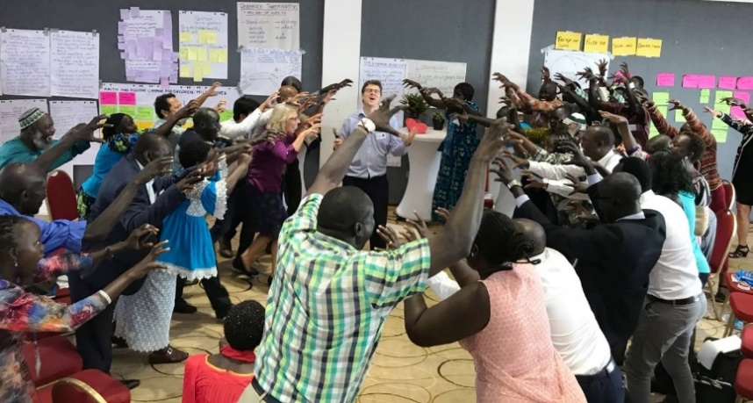
"The walls of our divides, God washed out during the last four days. It is amazing to be able to melt into one another so that we can work together for the common good of our children and our people. I learned that it is not a workshop; it is WorkRock… you engaged in building a solid foundation ….. I saw this was a serious business…. "

ANNEX 1: SOUTH SUDAN FPCC JOURNEY OF CHANGE

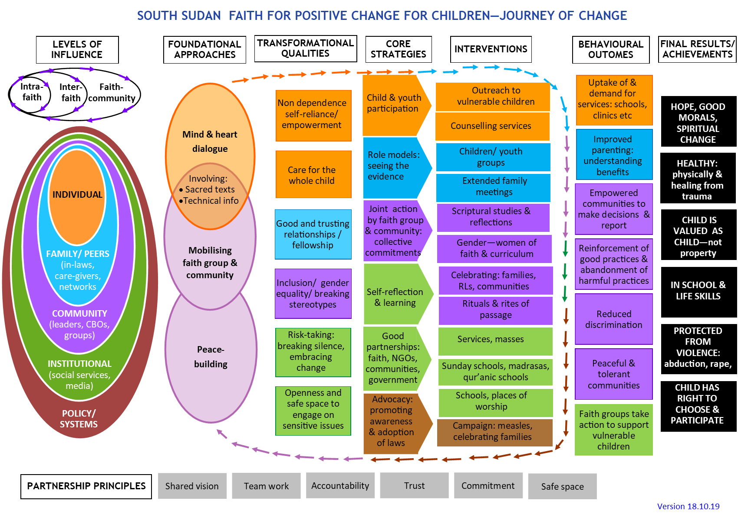

ANNEX 2: ACTUAL WORKROCK AGENDA
DAY 1: BREAKING BARRIERS – ESTABLISHING TRUST AND SHARING LEARNING

Time | Process
8am | Objective: A relaxed space for people to meet and begin to know each other  Arrival, registration and ‘Bingo’ ice-breaker
8.30am | Objective: A shared faith/ ethics driven responsibility to protect and support children  Welcome: Framing the WorkRock; introducing facilitators; ‘who is in the room’ exercise  Connecting faith and childhood:  - First memories of ‘faith and childhood’ – individual and small group reflection  - Sacred text learning about our attitude and responsibility for children  - Faith symbol reflection: laying down burdens and biases
10.30am | BREAK
11am | Objective: A safe place with expectations managed and guidelines for working together  Scene-setting  - Timeline for the FPCC initiative pre- and post-WorkRock  - ‘Power walk’: exercise to surface the barriers that different people face to participation and develop guidelines for our time together  - Laying down of our titles/ roles  - Check-in on outcomes and process for the WorkRock
1pm | LUNCH – in family groups to choose a name for the group
2pm | Objective: Shared learning about the impact of our FPCC work on children & society  Energiser: ‘Who began the movement?’  Most Significant Change stories – behavioural outcomes and results for children  - Listening well: skit showing bad and good listening to draw out lessons  - ‘Change group’ sharing of Most Significant Change stories, documenting any lasting behavioural changes and results for children  - Group selection of one story of most sustainable and systemic impact
3.30pm | BREAK
3.50pm | Objective: Draw out the learning about what makes effective FPCC approaches  Plenary stories of change – foundational approaches and core strategies  - Plenary telling of each selected story by half the groups  - Analysis what most helped to bring about and sustain the changes  - Formation of a wall chart journey of change based on the learning from the stories  - Sharing of FPCC Initiative learning linked to these areas  Wrap-up: Temperature check on the day; housekeeping; and explain evening activity.
5pm | CLOSE OF DAY
Evening | Case study preparation for activity next day

DAY 2: SHARED COMMITMENT TO A NEW WAY OF WORKING TOGETHER IN FPCC

Time | Process
8.30am | Objective: Drawn out the journey of change from participant and external experience  Welcome and scene-setting for the day  - Pass the mic review and process for the day  - Check-in on WorkRock guidelines  Case study analysis – a new way of working in FPCC programming  - Fruit salad energiser to mix up participants  - Case study group sharing in groups of three, drawing out learning from each case study and selecting three key points to share.  - Plenary feedback of case study learning, linking back to findings from day 1.  Plenary stories of change – foundational approaches and core strategies  - Plenary telling of remaining stories  - Analysis of what most helped to bring about and sustain change, adding to wall chart
10.30am | BREAK
11am | Objective: Surfaced hidden biases and internal/ external hindrances and helps for change  Childhood roadmap  - Personal story and faith symbol reflection  - In peer pairs, draw childhood journey, mapping ups and downs, and analysing the role that faith and other internal and external factors played in helping and hindering  - Feedback views of the children today from the formative research – wearing hats to represent girl and boy child perspectives  - Draw out the influences on children to add to the wall chart  - ‘Change group’ reflection on how we perpetuate the cycle of violence
1pm | LUNCH
2pm | Objective: Heart and mind understanding of a new way of partnering for systemic change  A new way of working together – living out partnership  - Balloon icebreaker: exercise on the importance of planning and working together  - Changing hats: ‘change groups’ explore the roles of different partners and the qualities that would enable each to contribute effectively to positive change for children  - Bean rank qualities with discussion about what is important and why
3.30pm | BREAK
3.50pm | Objective: Drawn together learning from the day and reviewed the sessions  Energiser: ‘Sampson and Delilah’  Plenary feedback  - Feedback and discussion of partnership exercise  - Gallery walk to review ‘change group’ reflections on perpetuating the cycle of violence  Wrap-up: housekeeping; individual feedback forms. Give out resource and guidance docs.
5pm | CLOSE OF DAY
Evening | UNICEF team preparation of drivers of child marriage drama

DAY 3: MODELLED AND EMBEDDED IN HEART AND MIND A NEW WAY OF WORKING

Time | Process
8.30am | Objective: Internalised and shared ideas to strengthen the resource and program guides  Welcome and scene-setting for the day  - Welcome and prayer  - Recap of the WorkRock progression  - Summary of group priorities for partnership qualities/ principles  Journey of Change reflection  - Summary of the WorkRock learning and emerging journey of change  - Presentation of the draft journey of change for the Global FPCC Initiative  - Paired review: What is similar/ different? most important? missing or wrong?  - Plenary feedback and refinement of the journey of change  - Individual and plenary reflection about what this means for the way we work.  Modelling a new way of working together  - ‘String game’ in pairs: working out a solution together  - Plenary lessons for how to work together, recapping on helps, hindrances, principles
10.30am | BREAK
11am | Objective: Understood the context and drivers of child marriage using range of sources  The drivers of child marriage  - Introduce the positive change planning cycle and templates for planning  - Drama and plenary discussion, demonstrating and drawing out drivers of child marriage  - ‘Change group’ review of the different types of drivers of child marriage and prioritisation of the three most important in their context
1pm | LUNCH
2pm | Objective: Developed a journey of change for child marriage  Planning together for tackling child marriage  - ‘Change group’ building of a journey of change for child marriage, from the behavioural outcomes to the foundational approaches, strategies and interventions to achieve them  - ‘World Café’ sharing of group journeys of change for child marriage, with one person explaining and the rest of the group circulating
3.30pm | BREAK
3.50pm | Objective: Developed listening skills and encouraged everyone that change is possible  Working, learning and being accountable together  - As and Bs energiser to mix people up  - Mind, heart and feet listening: personal change stories  - Plenary sharing of some stories  Wrap-up:  - Summary of the feedback from day 2 and how it has shaped the day  - Group review of the day and commitment to tackle child marriage
5pm | CLOSE OF DAY

DAY 4: PLANNED HOW TO TAKE FORWARD THIS NEW WAY OF WORKING IN OUR CONTEXT

Time | Process
8.30am | Objective: Shared commitment to take forward the partnership for children  Welcome and review  - Welcome, prayer and sacred text reflection from 1 Peter 1:13  - Participant presentation of the South Sudan FPCC journey of change and story of putting foundational approaches into practice  - Recap of the ‘mind and heart dialogue’ WorkRock tools and line of agreement to show level of confidence in using them with others  Personal commitment  - Exercise: Defenders balloon game  - Faith symbol reflection, leading to individual commitments  Collective commitment  - Examples of the power of collective commitments  - ‘Day of the girl child’ collective commitment and photos
10.30am | BREAK
11am | Objective: Developed regional workplans to take forward the partnership for children  Action planning for taking forward the FPCC initiative in each region  - ‘Secret box’ exercise to show the expertise of communities to solve their own problems  - Regional group planning on how to take forward work together: getting the right people on board and building vision together; listening and prioritising; strategy design: identifying champions and resources; implementation; and monitoring
1pm | LUNCH
2pm | Objective: Agreed organisational/ group action plans and reviewed the WorkRock  Energiser: ‘Mexican wave’  Taking forward the initiative as groups/ organisations and together  - Individual reflection and developing of organisational/ group plans  - Individual evaluation: detailed feedback on process  - Plenary ideas for how to keep in touch across the broader group  - Jungle energiser symbolising the partnership spirit
3.50pm | Objective: Shared learning and inspired each other to take forward actions  Has it all been worth it?  - Introduction of UNICEF Section Chiefs  - Pass the mic reflection: What has stayed with from the week? What will I do differently or better, going forward?  Wrap-up  - Closing words from UNICEF Acting Country Representative and Archbishop  - Prayers and close
5pm | CLOSE OF WORKROCK

ANNEX 3: SACRED TEXTS ABOUT OUR RESPONSIBILITY TO CHILDREN
(Feedback from WorkRock participants and Sacred Texts quoted)

- The importance of teaching children clearly and without violence: “Start children off on the way they should go, and even when they are old they will not turn from it.” (Proverbs 22: 6)
- The importance of honouring your children: “Fathers, do not exasperate your children; instead, bring them up in the training and instruction of the Lord.” (Ephesians 6:4)
- Fathers support the mothers and children: “Mothers may breastfeed their children two complete years for whoever wishes to complete the nursing [period]. Upon the father is the mothers' provision and their clothing according to what is acceptable.” (Qur’an Surah Al-Baqarah 2:233)
- The importance of providing a faithful, loving foundation: “Then people brought little children to Jesus for him to place his hands on them and pray for them. But the disciples rebuked them. Jesus said, ‘Let the little children come to me, and do not hinder them, for the kingdom of heaven belongs to such as these.’ ¹⁵ When he had placed his hands on them, he went on from there.” (Matthew 19: 13-15)
- Female children are a blessing, so it is important to protect and care for them – not bury them: “And when one of them is informed of [the birth of] a female, his face becomes dark, and he suppresses grief. He hides himself from the people because of the ill of which he has been informed. Should he keep it in humiliation or bury it in the ground? Unquestionably, evil is what they decide”. (Qur’an, 16:58-59).
- The importance of teaching children diligently – in what we say and do and how we behave: “These commandments that I give you today are to be on your hearts. Impress them on your children. Talk about them when you sit at home and when you walk along the road, when you lie down and when you get up.” (Deuteronomy 6: 6-7)
- Be careful to follow God and provide for the children: “come I will recite what your lord has prohibited you from: Join not anything in worship with Him; be good and dutiful to your parents; kill not your children because of poverty-We provide sustenance for you and for them.” (Qur’an 6: 151)
- The importance of providing guidance, direction and love – the rod was used to guide and to protect sheep from predators: “Whoever spares the rod hates their children, but the one who loves their children is careful to discipline them.” (Proverbs 13: 24); “Do not withhold discipline from a child; if you punish them with the rod, they will not die.” (Proverbs 23:13)
- The responsibility of parents and the whole community to protect vulnerable children: “And do not approach the orphan's property except in a way that is best until he reaches maturity. And give full measure and weight in justice. We do not charge any soul except [with that within] its capacity. And when you testify, be just, even if [it concerns] a near relative. And the covenant of Allah (SWT) fulfil. This has He instructed you that you may remember”. (Qur’an 6:152)
- The importance of protecting children: “He called a little child to him and placed the child among them. And he said: ‘Truly I tell you, unless you change and become like little children, you will never enter the kingdom of heaven. Therefore, whoever takes the lowly position of this child is the greatest in the kingdom of heaven. And whoever welcomes one such child in my name welcomes me. If anyone causes one of these little ones – those who believe in me – to stumble, it would be better for them to have a large millstone hung round their neck and to be drowned in the depths of the sea’.” (Matthew 18: 2-6)
ANNEX 4: PARTICIPANT LIST

NAME | GROUP/ ORGANISATION | ROLE

