Framework for Regional Faith Engagement Strategy for South Asia

- Introduction
In 2018, UNICEF, in partnership with the world’s largest convenor of faiths Religions for Peace and knowledge partner and member organization of FBOs, Joint Learning Initiative (JLI) launched a new initiative - Faith and Positive Change for Children, Families and Communities (FPCC) initiative. The aim of the initiative is to support evidence-based integrated framework for faith-based leadership for SBC and faith influence for positive change. FPCC came with the goal of establishing more strategic, sustainable and effective partnerships with Religious leaders, local Faith communities and FBOs through a new way of working that is more collaborative, community asset-based, integrated, and wholistic.
  - FPCC Theory of Change
In 2019, the FPCC Theory of Change and Mind-Heart Dialogue foundational approach was developed, tested, adapted and validated in 5 country WorkRocks in Easterm, Southern and West Central Africa, and in consultation with the FPCC Advisory group including representatives from the tripartite partners. A WorkRock is a concept for an in-depth consultation and planning meeting with Faith partners as the foundation for a new way of working on strategic faith engagement.
  - FPCC and COVID-19 Response
In 2020, FPCC in response to the global COVID-19 Pandemic, re-purposed its workplan to launch a global Faith-in-Action initiative to address 6 priorities of the pandemic: Addressing Misinformation and Rumours; Stigma and Discrimination; Adaptation of Mass Gatherings and Rituals; Violence Against Children; Addressing Vulnerable Groups; Children and Youth Participation and Supporting Recovery of Social Services.
  - Global Consultations
Supported by the tri-partite partnership (Religions for Peace, JLI and UNICEF), a series of 7 Regional webinars and one global FBO consultation webinars were convened to learn about existing efforts, issues and needs related to the pandemic and to make plans. A set of 6 global guidance document on the priority issues were co-created and a virtual WorkRock training series developed and piloted with Religions for Peace Inter-religious councils, FBOs and UNICEF in 6 countries Eastern and Southern Africa to train religious leaders and FBOs to roll out the FPCC approach, supported by Global Guidance documents, resources and a technical team from JLI.
  - Consolidating the Gains
In 2021, in collaboration with a Faith-based training institute CORAT, a FPCC training model was developed and implemented by the tripartite partnership, focusing on Regional Master training in ESAR and WCAR regions using the Mind-Heart Dialogue Facilitators manual, followed by country level WorkRocks in 8 selected countries.

- UNICEF ROSA Engagement
UNICEF’s Regional Office for South Asia (ROSA) has engaged in past years to forge partnerships with religious leaders. It facilitated the launch of the first South Asia Religious Leaders’ Platform for Children in Kathmandu in 2017 to promote child rights. Following up on the initiative, a high-level dialogue entitled South Asia Religious Leaders Platform for Children was held on 28–29 January 2020 in Bhutan. Again, in April 2020, ROSA convened a virtual gathering of nearly 30 prominent religious and religious leaders of Muslim, Hindu, Buddhist and Christian faiths from across South Asia to mitigate the devastating impact of COVID-19 on vulnerable communities and the rising incidents of discrimination, stigma, fear, and violence at home and in public places.
  - Consultations on Regional Faith Engagement Strategy for ROSA
The launch of the Regional Faith Leaders forum for South Asia was held virtually on 8th December 2021 with the following Plan of Action agreed:
- To develop a roadmap to further contribute to a coordinated Regional Faith Engagement Strategy
- To formalize a Regional Advisory Group of Faith Actors in South Asia
- To support mapping of existing faith engagement work of different organizations in the region to facilitate strengthened collaboration between religious leaders, faith-based organizations and international organizations to advance child rights
  - Regional Faith Engagement Forum for ROSA
In the framework of Faith for Positive Change for Children Initiative launched in December 2021 during the Faith Engagement High Level Meeting, a regional Faith Leaders Engagement Forum (The Forum) for South was held in Kathmandu, Nepal, on May 8th-10th. This meeting brought together partners from Joint Learning Initiative for Faith and Local Communities (JLI), UNICEF South Asia, Faith Based Organizations and Inter-religious Councils from the eight countries (Afghanistan, Bangladesh, Bhutan, India, Nepal, Maldives, Pakistan and Sri Lanka).
The initiative encapsulated the following thematic areas, under an umbrella headline of Accelerating Progress for Adolescent Girls:
- End Child marriage
- Revolutionize learning
- Mental health
- Fostering Leadership by Girls & Women in a Changing World
This framework outlines the three year regional strategy for faith engagement in ROSA.
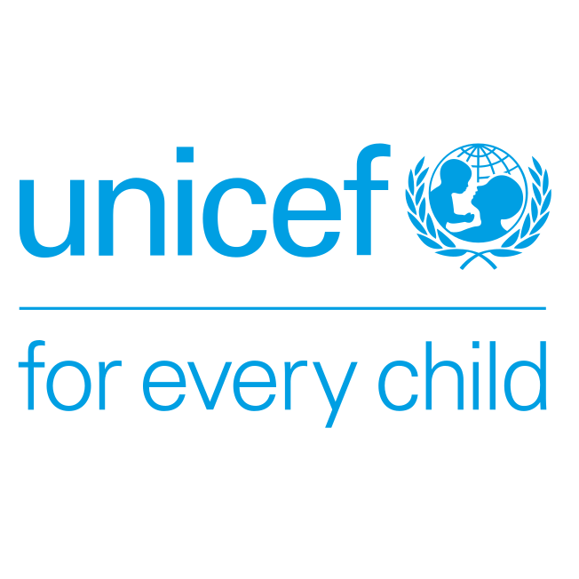
- ROSA Faith Engagement Strategy 2022/2023, 2023/2024, 2024/2025
 | Pillar | Proposed Activities | Year 1 | Year 2 | Year 3 | Budget | Assets/Resources
1 | Capacity strengthening | - Development of regional capacity strengthening strategy through mapping and formative research on available resources, needs, opportunities and priorities.
 |  | - Establishment and roll out of a coordinated long-term partnership training Mind and heart dialogue training model for Country level FPCC stakeholders.
 |  | - Building on the existing capacities of religious leaders, women and youth faith networks and FBO personnel to establish a pool of master trainers, country trainers and facilitators.
 |  | - Implementation of religious literacy training for UNICEF/development partner staff to ensure mutual transformation on faith engagement across all programme sectors.
 |  | - Embedding of faith engagement and Mind and Heart approaches in the UNICEFE ROSA programme cycle
- Issue prioritization, mapping and planning for capacity strengthening on thematic areas of :
  - End Child marriage
  - Revolutionize learning
  - Mental health
  - Fostering Leadership by Girls & Women in a Changing World

 |  | - Cascaded orientations and capacity strengthening on thematic area at Country level
2 | Regional Resources and Tools | - Formation of Regional Technical Working Group on Training
 |  | - Adoption, adaptation, translation, development and promotion of technical resources/tools based on regional priorities and contexts
- Development and production of region specific resource guides on:
- Ending Child marriage
- Revolutionizing learning
- Mental health
- Fostering Leadership by Girls & Women in a Changing World
 |  | - Dissemination an deployment of guides
3 | Coordination | - Formation and support of Regional Advisory Group for Faith Engagement
 |  | - Development and launch of Regional Faith Engagement Strategy
 |  | - Establishment of Regional and Country co-ordination mechanism through MFACCs
4 | Evidence and feedback generation | - Listening to voices of children and youth through Polls (online, U Report) | Conduct online and U Report polls with faith communities, this will require promotion of U Report
 |  | - Feedback reporting through women and youth of faith, congregational groups and FBO networks | As part of social listening and community feedback collection process, interfaith focal points to collate and report feedback periodically
5 | Digital engagement | - Deploy content and materials to congregational, youth and women of faith networks through Internet of Good Things (IOGT) | IOGT to deploy content and materials from the FPCC/interfaith campaigns adapted to meet the local needs and contexts
 |  | - Continued feedback and engagement with youth, women of faith and congregational/community networks through WhatsApp communication trees/ Email mailing lists | WhatsApp groups and email lists to be created at regional, country and local levels, using available contact details of faith actors and stakeholders |  |  |  | Repository of phone numbers and email addresses of FBO representatives, interreligious councils, UNICEF focal points
6 | Social media and advocacy | - Social media campaign | In collaboration with UNICEF ROSA external communication teams, develop social media assets
 |  | - Joint interfaith public statements (country-level) | In collaboration with influential religious leaders, UNICEF country offices, FBOS, produce a signed statement inspired by the global statement
 |  | - Advocacy briefs | Develop faith-sensitive advocacy brief for priority decision-makers
7 | Documentation and Learning | - Development of case studies, success stories, and Most Significant Change stories | With guidance from and in collaboration with JLI – the knowledge partner for the FPCC initiative, collect insights to inform messaging and strategies from time to time
8 | Research, Monitoring and Evaluation | - Establishment of a Regional TWG for Research and M&E
 |  | - Develop a Research, M&E Strategy
 |  | - Identify and prioritize research and learning priorities and actions

