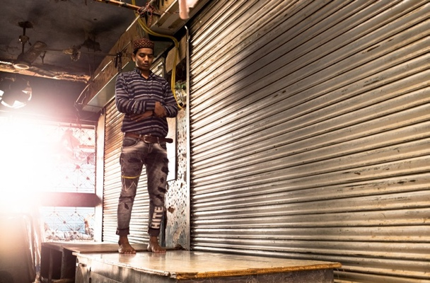
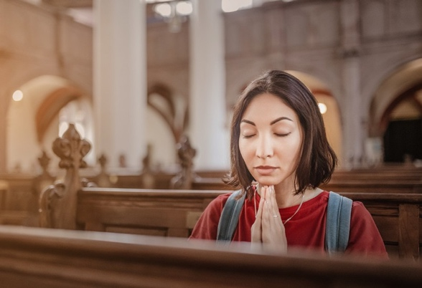
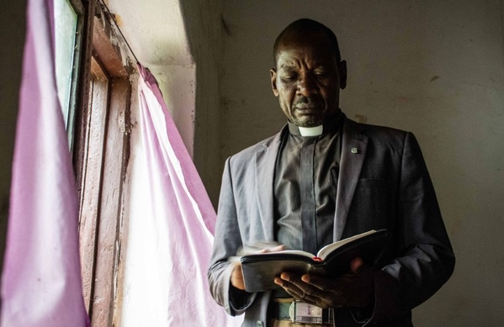
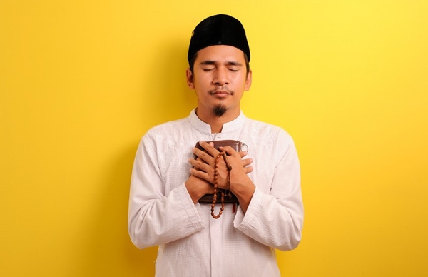
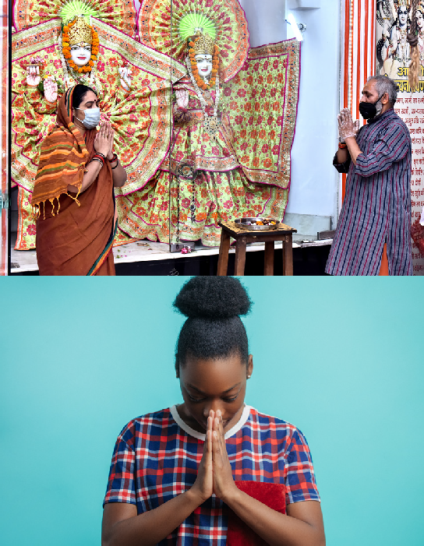
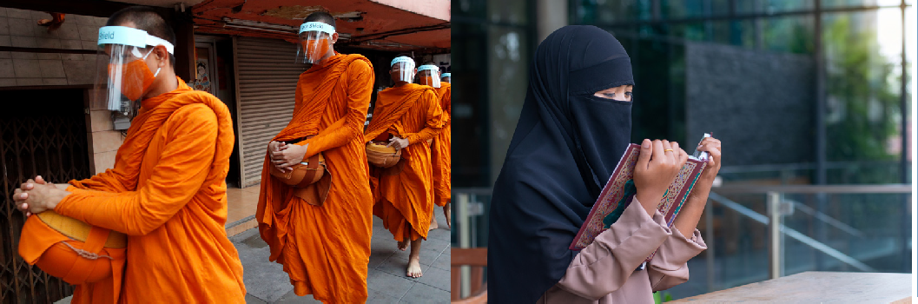
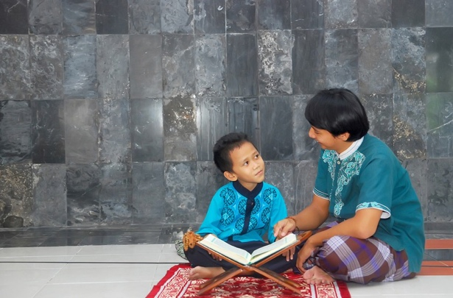
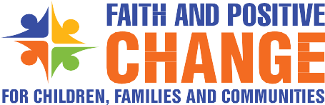
COVID-19
PRACTISING OUR FAITH SAFELY DURING A PANDEMIC

HELPING PEOPLE WHO ARE AT RISK

Resource Guide for Religious Leaders and Faith Communities

Cover photo credits (clockwise):

Bangkok / Thailand April 2, 2020: Thai Buddhist monks wearing face shields to protect themselves from Covid-19 collect morning alms By Thavorn Rueang

Muslim woman reading Holy Quran praying for God to bless her in a public place By chomplearn

Portrait of male surgeon praying in an operation theater at a hospital. Healthcare workers in the Coronavirus Covid19 pandemic By wavebreakmedia

A young Asian father teaches a child to read the Holy Quran By Aidil Akbar

A priest and a devotee wear masks and maintain social distance while offering prayers at a temple in Ghaziabad, Uttar Pradesh, India By Ashutosh Sharma

A woman, holding a holy text, bows her head with her hands raised in prayer By UfaBizPhoto

Migrant labourers who failed to reach their native villages after lockdown offer (Namaz) prayers besides the closed shop where they used to work.
By A. Mukjherjee

A portrait of a man holding Holy Quran and prayer beads By Heru Anggara

A woman raises her hands in prayer, seated in the pews of a church By frantic00

Reverend Tito Ringanza, the Provincial Secretary of Episcopal Church of South Sudan, reads a Bible at his office in Yambio,
South Sudan, March 2020. Rev. Tito’s mother died in the 1976 Ebola outbreak. Reverend Tito’s church spends time during church services to educate people on how to take care and protect themselves from Ebola virus.
By Brian Ongoro

BACKGROUND ON THE GLOBAL MULTI-RELIGIOUS FAITH-IN-ACTION COVID-19 INITIATIVE

Faith and Positive Change for Children, Families and Communities (FPCC) https://www.faith4sbcc.org/
HELPING PEOPLE WHO ARE AT RISK
is a global partnership between the United Nations Children’s Fund (UNICEF), the world’s largest inter-faith network Religions for Peace (RfP), and knowledge partner Joint Learning Initiative on Local Faith Communities (JLI). FPCC was conceived in 2018 to move beyond single sector, siloed, ad-hoc and sometimes instrumentalist approaches of faith engagement in development work and was officially launched by RfP and UNICEF’s Executive Director in Washington DC in October 2019.

The central aim of the partnership is to support positive social and behaviour change with and for children, parents and communities with specific emphasis on going beyond simply delivering messages, to engaging faith communities in self-reflection, dialogue, exchange and feedback in order to achieve lasting positive change on jointly agreed priorities affecting children and their families. After a year of evidence generation, development of 17 country case studies, reviews of existing resource guides and development of a Theory of Change, the partners agreed to work together more systematically and deeply in keeping with the new engagement model in six African “Early Adopter Countries”.

In the last quarter of 2019, a process of country level “WorkRocks” was initiated to pilot the new way of coordinating planning and action of UNICEF country offices with their respective Inter-Religious Councils and the local offices of international faith-based organizations.

In February 2020, in response to the COVID-19 worldwide pandemic, the FPCC partners agreed to immediately shift focus of its joint workplan to
respond to the international crisis through a new global multi-religious Faith-in-Action initiative to provide coordinated and evidence-based inter-faith support
for the protection and well-being of children and their communities. UNICEF’s Executive Director signed a joint global statement and call to action on the COVID-19 response with 12 of RfP’s most senior religious leaders. https://rfp.org/launch-of-global-multi-religious-faith-in- action-covid-19-initiative-2/ https://www.unicef.org/press-releases/launch-global- multi-religious-faith-action-covid-19-initiative.

The initiative aims to mobilize religious leaders, faith communities, women of faith, and youth networks within RfP through its Inter-Religious Councils at country level to support COVID preparedness and response.
The key objectives of the campaign are to:

- Manage communication, address misinformation and rumours
- Dispel fear, stigma, discrimination, and promote social harmony
- Promote adaptation of religious gatherings, practices, rituals, handwashing and hygiene
- Address specific needs of vulnerable groups
- Promote the prevention of violence against children and women
- Promote the participation of children and young people and their active engagement in the initiative
- Promote and support the recovery of social services, resilience and return to normalcy

In order to achieve the above objectives, the Faith-in- Action initiative has outlined the following strategies:

- High level advocacy at global, regional and country level
- Generation and analysis of faith-related behavioural evidence to inform action
- Development, dissemination and local customization of global guidance on key thematic issues
- Periodic webinars at the different levels for sharing of knowledge, issues and experiences
- Digital engagement and capacity development
- Tracking, monitoring and documentation of the results of the initiative.

Working with UNICEF, RfP and many other partners, JLI developed a Global Reference Document https://jliflc.com/resources/multi-religious-faith-in- action-covid-19-initiative-reference-document-ed-1/ to inform the development of series of COVID-related specific thematic guides.

This package of thematic Guides is aligned with and are expected to support the achievement of each of the 7 objectives of the Multi-Religious Faith-in-Action
COVID-19 global initiative as outlined in the background.

The Guides have been designed specifically for use, updating and adaptation by religious leaders, faith communities and FBOs at country and
community-level with support from UNICEF and other humanitarian and development partners to support the implementation of the Faith-in-Action initiative.

For questions on the guides please contact: Kerida McDonald kmcdonald@unicef.org Deepika Singh dsingh@rfp.org

1

ACKNOWLEDGMENTS

This Faith-in-Action guidance document would not have been possible without the invaluable inputs of many colleagues from the three main partner agencies that contributed to the development and compilation. We take the opportunity to acknowledge and express appreciation to the main writers and reviewers:

Joint Learning Initiative:
Olivia Wilkinson, Jean Duff, Stacy Nam, Susanna Trotta, Ellen Goodwin

Religions for Peace (RfP):
Deepika Singh, Dr Francis Kuria, Jimmy Otieno,
Kyoichi Sugino, Sarah van Bentum, Maddalena Maltese, Mary Grace Donohoe and Christopher Zefting

UNICEF:
Kerida McDonald, Carlos Navarro Colorado, Sonia Sarkar, Ivan Amezquita, Julianne Birungi, Ken Dawson, Massimiliano Sani, Johary Randimbivololona,
Sahar Hegazi, Ken Limwame, Christine Heckman, Eric Dentor, Mariana Zaichykova

UNICEF Interns:
Snigdha Suvarna (Occidental U.), Ishanya Anthapur and Shanaz Deen (Princeton U.)

C4D Consultant:
Ami Sengupta

In addition, we would like to express gratitude to all the religious leaders and organizations that supported the review and feedback on the documents in alphabetical order by organization

Religious Leaders, Religions for Peace:
Bhai Sahib Mohinder Singh, Prof. Anantanand Rambachan, Ms. Bani Dugal, Mr. Homi D. Gandhi, Ms. Ravinder Kaur Nijjar

International Faith Based Organizations and Associates:
  - ACT Alliance, Thorsten Göbel
  - Adventist Development & Relief Agency, Imad Madanat, Sonya Funna
  - Anglican Alliance, Rachel Carnegie, Janice Proud
  - Arigatou: Rebecca Rios-Kohn, Maria Lucia Uribe
  - American Jewish World Services, Ruth Messinger
  - Dan Church Aid, Jørgen Thomsen
  - Emory University Interfaith Health Program, John Blevins
  - Episcopal Relief and Development, Abagail Nelson, Nagulan Nesiah
  - Humanitarian Forum Indonesia, Yusuf Ali, Dear Sinandang

- FADICA, Alexia Kelley
- Islamic Relief Worldwide, Atallah Fitzgibbon
- Kirk In Actie, Corrie Van der Ven
- Mothers Union, Rob Dawes
- Organization of African Instituted Churches, Rev Nicta Lubaale
- Sally Smith
- Soka Gakkai, Noboyuki Asai
- Salvation Army, Bram Bailey
- Sarvodaya, Vinya Aryaratne
- Tearfund, Catriona DeJean
- World Council of Churches, Masimba Kuchera, Frederique Seidel
- World Evangelical Alliance, Christine McMillan, David Boan
- World Faith Development Dialogue, Katherine Marshall
- World Vision International, Andrea Kaufmann

Development Agencies:
- Gratitude is due to the following individuals from development agencies who provided inputs for the guides:
- Food for the Hungry, Luis Noda
- Global Water 2020, Lindsay Denny
- International Federation of Red Cross and Red Crescent, Amjad Saleem
- USAID CFOI, Kirsten Evans
- US Dept Health and Human Services, Heidi Christensen
- WHO, Sarah Hess
- World Bank, Mercy Niwe

Design and Photography:
We are grateful to Donna Rajeh for the design and layout of the document, to Fortuneight Pvt. Ltd for their voluntary support for the abridged slide decks and strategic inputs to the guidelines, to Ashutosh Sharma, Anandito Mukherjee, and Thomas Sampson, for many of the original photographs.

Translation and proofreading:
Special thanks also to SIL International who voluntarily assisted with proofreading of the English language documents and translation of the slide decks of the guidelines into other languages. The team was led by Paul Frank.

HELPING PEOPLE WHO ARE AT RISK
2

HELPING PEOPLE WHO ARE AT RISK

CONTENTS

BACKGROUND ON THE GLOBAL MULTI-RELIGIOUS FAITH-IN-ACTION COVID-19 INITIATIVE
1

2 ACKNOWLEDGMENTS
7 ISSUES

IDENTIFYING PEOPLE AT GREATER RISK FROM COVID-19
8

WHAT CAN RELIGIOUS LEADERS AND FAITH COMMUNITIES DO
10

RELIGIOUS TEACHINGS AND SACRED TEXTS
12

IDEAS FOR DIALOGUE AND ACTION
13

ADDITIONAL RESOURCES
14

JOINT CALL TO ACTION
17
3

YOUR ROLE AS A RELIGIOUS LEADER OR FAITH COMMUNITY
IN THE COVID-19 CAMPAIGN TO HELP GROUPS
AT RISK

Series 3: Resource Guide for Religious Leaders and Faith Communities

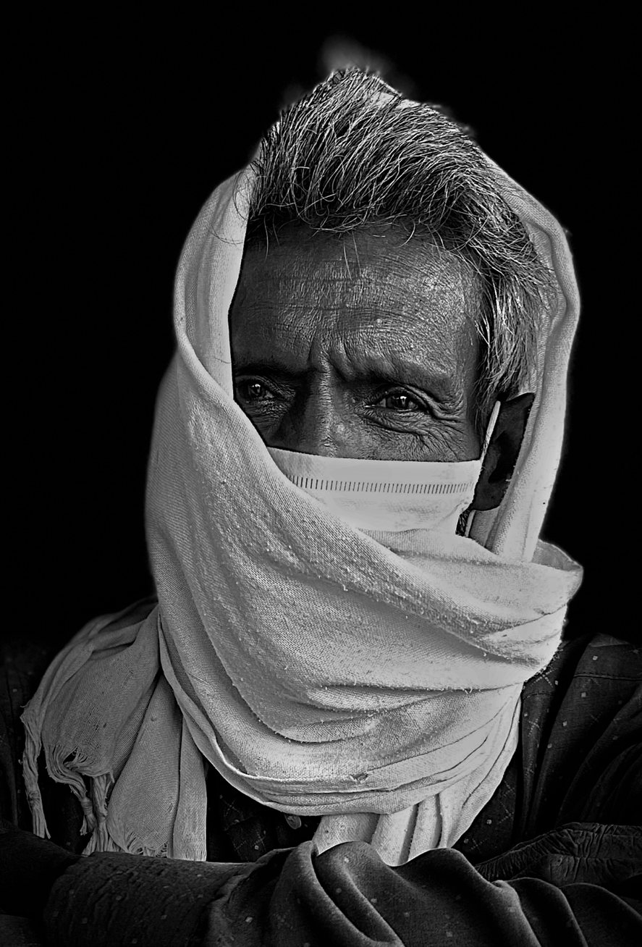
HELPING PEOPLE WHO ARE AT RISK

ISSUES

Certain groups of people are at greater risk of complications and death. These include the elderly and those with underlying health conditions such as diabetes, asthma, and heart disease. People with disabilities or weakened immune systems and those in nursing homes or long-term care facilities are also at risk. People living in crowded spaces with limited sanitation facilities like migrants, those living in poverty or in urban settlements, displaced populations, refugees, and people affected by humanitarian emergencies are also at risk and may not be able to practice the recommended preventive behaviours, especially physical distancing. Referred to as groups at risk or facing vulnerabilities, these people often are likely to suffer more negative consequences when crises occur.1

Religious leaders – through their position of trust – can establish valuable support and safety networks for these groups. They can also promote dialogue and action among communities to provide assistance and encourage values of solidarity, community and hope. The issues contributing to people’s vulnerabilities include:

  - Lack of access to health services and accurate information.
  - Higher risk of dying from the virus than other people (for certain groups e.g. the elderly).
  - Higher dependency on family members and caregivers for assistance.
  - Separation from family, community, and peer networks.
  - Limited capacity to understand and avoid risks.
  - Living in crowded households and settlements lacking adequate hygiene and sanitation facilities.
  - Living in extreme poverty, dependent on the informal economy or daily wages, without the resources for survival for long periods of isolation
and self-quarantine.
  - Often not included in national response plans and marginalized in many ways.
  - Affected by multiple factors like other outbreaks of diseases, climate-change effects, other disasters such as floods and conflict.
  - At risk of violence, abuse, and exploitation.

An elderly migrant labourer waits for a bus to take him back to his village, during the COVID-19 lockdown in India
By Anindito Mukherjee

7

IDENTIFYING PEOPLE AT GREATER RISK FROM COVID-19
While these groups are diverse, what they have in common is their limited access to support and services, as well as their lower ability to cope with crises such as pandemics. Vulnerable or at-risk groups are less prepared or able to plan for disasters, prevent them, cope with them, or recover from them. For example, children, women, the elderly, those living with illnesses or in poverty tend to suffer more when emergencies or disasters strike.2,3 This section highlights seven categories of at-risk groups and explains key issues affecting each group.

  - The elderly and those with existing health conditions. People over 65 years of age and those living with existing health conditions are at the
highest risk of complications and death. Elderly people also depend on family or community members for their care, and often live alone. Social distancing measures and lockdowns will affect their care and provision of medical and food supplies.
The elderly may be less informed about the necessary precautions for COVID-19 and might find it difficult to keep themselves updated with current information and notices from the government.4
  - People living in extreme poverty.5 It is difficult, if not impossible, for people living in poverty to take preventive measures such as social distancing or
self-isolation. Poor housing conditions and crowded spaces, limited access to clean water, sanitation
and hygiene facilities, malnutrition and low literacy increase their vulnerability and exposure to risk.6 Informal settlements, especially in urban settings, are often not included in emergency response plans, in spite of their potential for rapid spread
of diseases.7 Poor families depend on the informal economy to survive and will find it difficult to stock up or stay at home and will be forced to expose themselves, and their children in particular, to risks for basic survival.8
- Children and pregnant women. Pregnant women are susceptible to COVID-19 risks and must always follow safety practices. At this point we do not
know if the virus can be passed on from a mother to the baby while she is still pregnant, but there is no evidence of the disease being passed through breastfeeding.9 Pregnant women will also face disruption of ante-natal health-care services, and hospital visits may be less frequent. Childbirth
at hospitals may also be a matter of concern if healthcare facilities are filled with COVID-19 cases. Post-birth, visitors will need to be restricted as far as possible.10

Though children are less vulnerable to the virus, they are affected by the pandemic because they depend on their adult caregivers for support and protection.11 The majority of the world’s children are not attending school during the pandemic and are faced with disruption of learning, and possibly increased violence at home and online;12 they may have more limited access to health and nutrition, as many had been relying on meals at school for proper nutrition.13
- People with disabilities. People living with mental or physical disabilities might require special assistance to meet their mobility, nutrition, and
hygiene needs. They might also need special communication strategies and guidance in changing their behaviour to minimize infection risk for themselves and for their caregivers.
- People experiencing discrimination. Often when health crises occur, minority groups are at higher risk of discrimination and stigma.14 People
who are considered“minorities” may suffer from discrimination, at times resulting in physical violence and social isolation.15 This can affect their capacity to follow recommended practices or seek care when they are sick. They may also have limited access to services and information and may be living in poverty or crowded housing with
limited mobility and access to water, sanitation, and hygiene facilities.

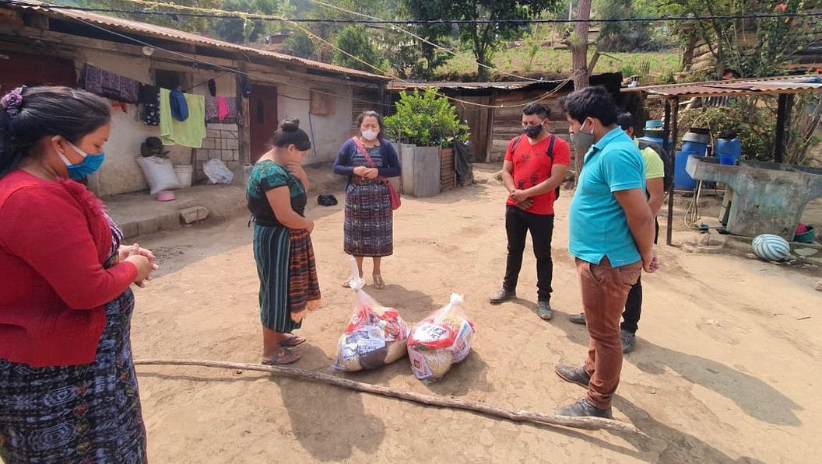
HELPING PEOPLE WHO ARE AT RISK
Relief work in Guatemala
By amslerPIX/Flickr (used under Creative Commons License)

8

  - People experiencing homelessness. Homeless people live and access services in settings where there are many other people (such as shelters,
public bathrooms, soup kitchens and meal services), which puts them at added risk of infection. Many people who are homeless already suffer from certain medical conditions and typically have
less access to health-care.16 People living on the streets cannot practise preventive behaviours like handwashing, social distancing, or disinfecting their surroundings, and they lack social support and safety networks.
  - People on the move. Migrant groups, seasonal workers, or internally displaced populations live in difficult conditions such as settlements and camps
with limited sanitation and hygiene facilities. Their living conditions are crowded, and social distancing is not possible. These groups also lack means
for basic survival, documentation, and status to guarantee their rights to various benefits, including healthcare, government schemes, subsidies, and information.17 People on the move also often experience many forms of discrimination.18
This list highlights some key groups who face greater risk from COVID-19, but there are other groups who have similar vulnerabilities, for example people in prisons or health institutions. Also, people living in countries affected by humanitarian conflicts or disasters experience similar risks.19 Religious leaders and faith communities will need first to identify the vulnerable groups within their communities and then adapt the response and support based on those people’s specific needs.

On 19 July 2018 in the Central African Republic, Pierre and his father in bed at the malnutrition stabilisation centre at the Bangui Paediatric hospital.
By Donaig Le Du

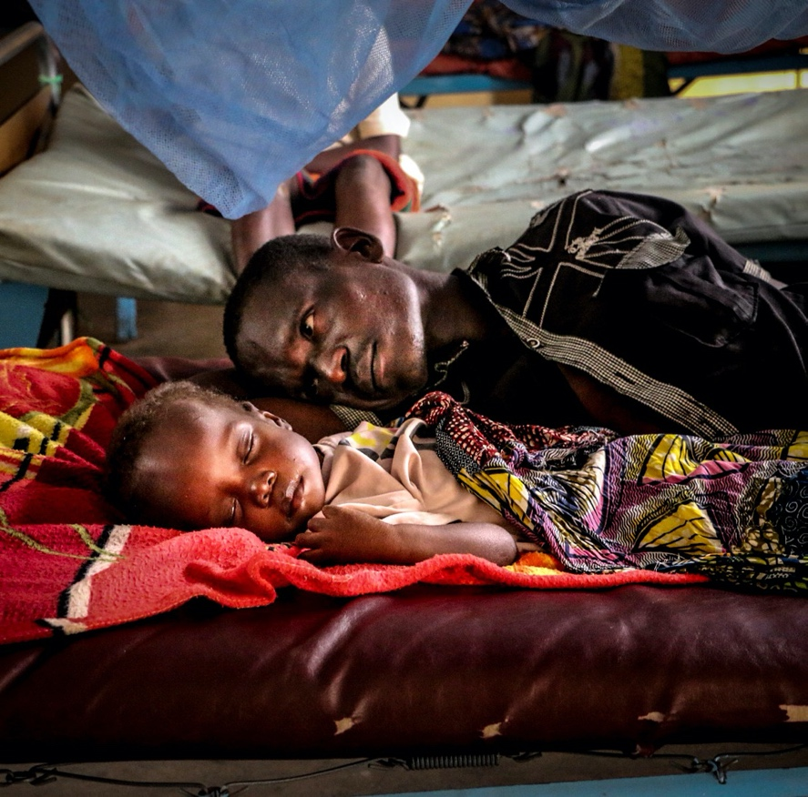

9

WHAT CAN RELIGIOUS LEADERS AND FAITH COMMUNITIES DO

Given the trust and respect religious leaders and faith communities command, they are well placed to mobilize people to help at-risk groups by providing emotional and spiritual counselling, food, money, shelter, or supplies. Religious leaders can clarify doubts and convey accurate information to avoid confusion and misinformation. They can also be intermediaries between government and local organizations. These are some specific ways to reach out and provide support:

Identify the most at-risk
Religious leaders and faith-communities can help local authorities identify groups who are at risk. Religious leaders, including youth and women’s leaders, live with and know their communities well. As a result, they are the best ones to identify people and groups who are at risk, and they can reach out to people to offer help.

  - Make a map or list of the people you are concerned about, to identify individuals and families at risk.20
  - Assess their needs as well as capacities and identify community assets, resources, and ways to provide support.21
  - Organize follow-up and monitoring, which can also serve as information and counselling opportunities. If physical follow-ups are not
possible, consider telephone and virtual check-ins.22
During the Ebola outbreak in Sierra Leone, local women and religious leaders established Community Watch Committees to bolster national efforts in sensitizing people to the risks of the disease and identifying possible cases.23

Adapt and respond to special needs

Different groups and individuals within these groups will have varied needs related to COVID-19. They may require particular ways to access COVID-19 information, practise preventive behaviours, such as handwashing or social distancing, avail of care and support if affected, or receive emotional and mental support. Consider these differences in needs when planning faith-led support.
- Identify communication needs, as some of these groups may have difficulty accessing or understanding health-related messages. For
example, the elderly may prefer different channels of communication and may not be able to access digital technology or social media.24 Those with disabilities or who do not speak the official language well (especially migrants or displaced populations) will need tailored messaging in Braille, sign language or other languages.
- Listen to and document the concerns and needs voiced by members of at-risk groups. Very often vulnerable groups are not consulted in local plans, and
their needs and realities are overlooked. Seek feedback and understand what is working well and what can be improved to meet their needs better; involve at-risk groups in response and recovery planning.
- Engage community-level volunteers and act as advocates who dialogue with the authorities to meet these different needs. For some communities,
the need may be provision of water and soap for handwashing; for others it may be monetary
support or food supplies during lockdowns.25 Act as advocates to gain supplies and additional support as well as funding for these groups.26
- Support access to essential services and care, and help respond to the needs of at-risk groups through volunteer and faith networks.27 Periodical check-ins,
timely communication during emergencies and support to seek health-care or social services28 can be lifesaving.
In response to the COVID-19 pandemic, Religions for Peace’s Interreligious Council in Peru is working to provide approximately 8,000 vulnerable asylum seekers, refugees, and migrants (around 2,000
families) with essential emergency-response materials including food, hygiene kits, and rent vouchers. https://rfp.org/interreligious-council-of-peru-provides- essential-supplies-to-venezuelan-refugees-asylum- seekers-and-migrants/

HELPING PEOPLE WHO ARE AT RISK

10

The International Network of Engaged Buddhists (INEB) has set up a fundraising initiative that has allowed distribution of food during the COVID-19 emergency to people living in extreme poverty, for instance in a Dalit (Untouchable) village in India.29 They have also issued a statement advocating for policies and resources to address the needs of vulnerable groups, and to call for more inter-ethnic and interreligious solidarity.30
Religious leaders and faith communities are also involved in combatting the pandemic of HIV and we can learn lessons from these efforts about how to support people who are stigmatized because of illness. In Cambodia, the Buddhist Leadership Initiative (BLI) supports families affected by HIV.
Trained monks offer group meditation and home visits to families and children affected by the disease and to other vulnerable children. The BLI also provides small amounts of money to children to help their families cover basic needs including education and health care. The monks provide spiritual as well as material aid. 32

11

Approach at-risk groups with respect and compassion
Religions for Peace Japan launched a project to hand- make and distribute masks to the most vulnerable population in response to a low supply of masks
in the country. It is utilizing its vast networks and experience working with social-welfare centres and support centres, to distribute the masks to refugees, people with disabilities, people experiencing homelessness, and healthcare workers. https://rfp.org/religions-for-peace-japan- disseminates-10000-masks-to-the-most-
vulnerable-2/

At-risk populations tend to be side-lined and discriminated against. It is important for religious leaders to promote care and respect for these groups while also practising and modelling respectful behaviour.

  - Speak out against stigma and discrimination towards at-risk groups based on their differences, such as age, ethnicity, illness or ability, occupation,
or economic status. Promote messages of harmony and respect for all human beings. Address the needs of these groups as human beings: their physical needs, but also their emotional and social needs, to overcome isolation and discrimination.31
- Respect people’s opinions, ways of living and perspectives, even if they are different. Accept these differences while sharing accurate information33
and suggesting alternatives that are safe and recommended during a pandemic to substitute for traditional rituals and rites of passage.34
- Promote empathy among your faith group and engage communities to support individuals and families at risk. Religious leaders can encourage
followers and volunteers to provide support and safety networks to those in need.35
- Address and counter fear, because at-risk groups may be targeted by rumours and threats. Religious leaders and faith communities can provide correct
information that is simple and easy to understand, while also providing reassurance, solidarity, hope and courage.36
The Hindu Forum of Britain provides advice on how to react to the COVID-19 crisis in a way that respects the needs of older adults and other vulnerable groups. They suggest that Mandirs move to online activities if possible, e.g. through streaming of kirtan, yoga, and other ways to keep connected during physical isolation. It also advises people living with older relatives to keep 2 metres distance at home and use separate bathrooms if the choice is available.

RELIGIOUS TEACHINGS AND SACRED TEXTS

Buddhism
  - “May I be a protector for those who are without protectors, a guide for travellers, and a boat, a bridge, and a ship for those who wish to cross over!
May I be a lamp for those who seek light, a bed for those who seek rest, and may I be a servant for all beings who desire a servant.” Bodhisatva Shantideva in the Bodhicaryavatara.

Christianity
  - “God loves mercy more than anything else as he has this to say, ‘For I desire mercy, and not sacrifice; and the knowledge of God rather than burned
offerings.’ (Hos. 6:6). Charity to the needy is one way of showing compassion. If a person assists the destitute and the weak, he is very compassionate.
Among the destitute, physically weak and the impoverished are victims of HIV and AIDS. [...] Let us help victims of HIV and AIDS [and other diseases] physically, financially and morally.” Ethiopian Orthodox Tewahedo Church, Developmental Bible.

Islam
  - The Holy Qur’an says, “My Lord! bestow on them (parents) thy Mercy even as they cherished me in childhood.” (17:23-24)

Hinduism
  - The Bhagavad Gita urges people to act selflessly for the welfare of others: ”Strive constantly to serve the welfare of the world; by devotion to selfless work
one attains to the supreme goal in life. Do your work with the welfare of others in mind.” (3.19-26).

Jainism
- All life is sacred, and every being has a right to live fearlessly to its maximum potential. Living beings need not fear those who have taken the vow of
ahimsa (non-violence). According to Jainism, protection of life, also known as abhayadānam, is the supreme charity that a person can make.

Judaism
- “Defend the poor and the orphan; deal justly with the poor and the destitute.” (Psalm 82:3)

Baha’i
- “Be kind to all peoples; care for every person; do all ye can to purify the hearts and minds of men; strive ye to gladden every soul. To every meadow be a
shower of grace, to every tree the water of life; be as sweet musk to the sense of humankind, and to the ailing be a fresh, restoring breeze. Be pleasing waters to all those who thirst, a careful guide to all who have lost their way; be father and mother to the orphan, be loving sons and daughters to the old, be an abundant treasure to the poor.” (Selections from the Writings of ‘Abdu’l-Baha)

Zoroastrian
- “Always do the right thing, without any expectations, because it’s the best way to live. Offer your support to those in need and help them return
back to a better life. By doing this, we will make others happy, make our world a better place, and that will bring us the best happiness for ourselves, too!” (Teachings of the Prophet Zarathushtra, from the Gathas)

Sikhism
HELPING PEOPLE WHO ARE AT RISK
  - “The wise exalted Sikh (Brahmgiani) of Waheguru (God) is always unstained, like the sun, which gives its comfort and warmth to all. The wise exalted Sikh
(Brahmgiani) of Waheguru (God) looks upon all alike, like the wind, which blows equally upon the king and the poor beggar.”(Guru Granth Sahib Ji, p.272)

12
Photo credits (clockwise):

Two young Sikhs wear face masks while attending an outdoor rally in downtown Washington DC.
By Tom Sampson

On 29 February 2020, Nour, 16, stands in her war-ravaged and now partially inhabited neighbourhood of Karm
Al-zaitoun in Homs city, Syria. By Abdulaziz Al-Droubi

A man offers Namaaz prayers under a tree, during the lockdown for COVID-19 in New Delhi, India.
By Anindito Mukherjee

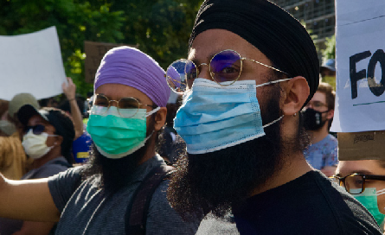
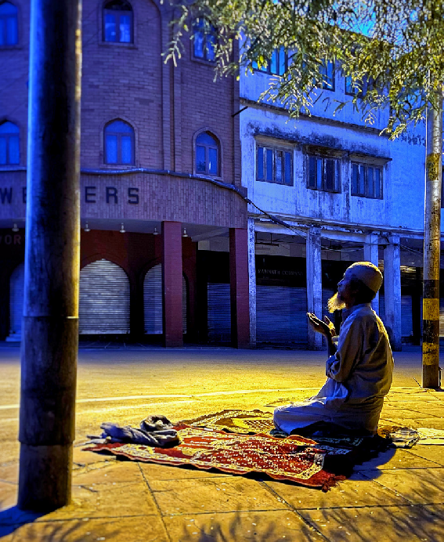
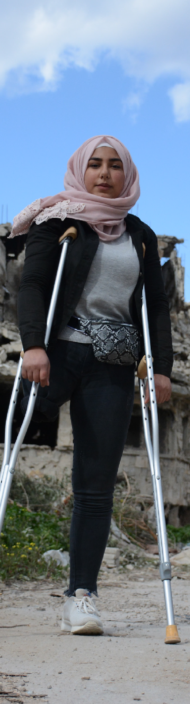
HELPING PEOPLE WHO ARE AT RISK

IDEAS FOR DIALOGUE AND ACTION

For religious leaders, your position and the role of faith becomes even more central in these troubled times. People will have a lot of questions, and there may not always be easy answers. The documents in the Multi-Faith Action for COVID-19 initiative provide more guidance on all of these topics and you can consult them for further information. As a starting place alongside your adaptations to religious gatherings and practice, you can also consider the following:

How do you connect with older and younger people in your faith community? Are there different and better ways to connect with varying age groups?

What are the different risks that people face in your community?

Share an example of collaboration with local authorities for adapting your religious gatherings and practices. Share
your written example by email (no more than 50 words) and a photo (150 pixels) if you have one.

info@rfp.org c4dunicef@gmail.com

CONNECT BACK WITH US!

How can we work on improving our respect and compassion for people who face particular risks?

13

How are community members helping each other? Do you run volunteer networks? What do your faith community volunteers work on?

ADDITIONAL RESOURCES

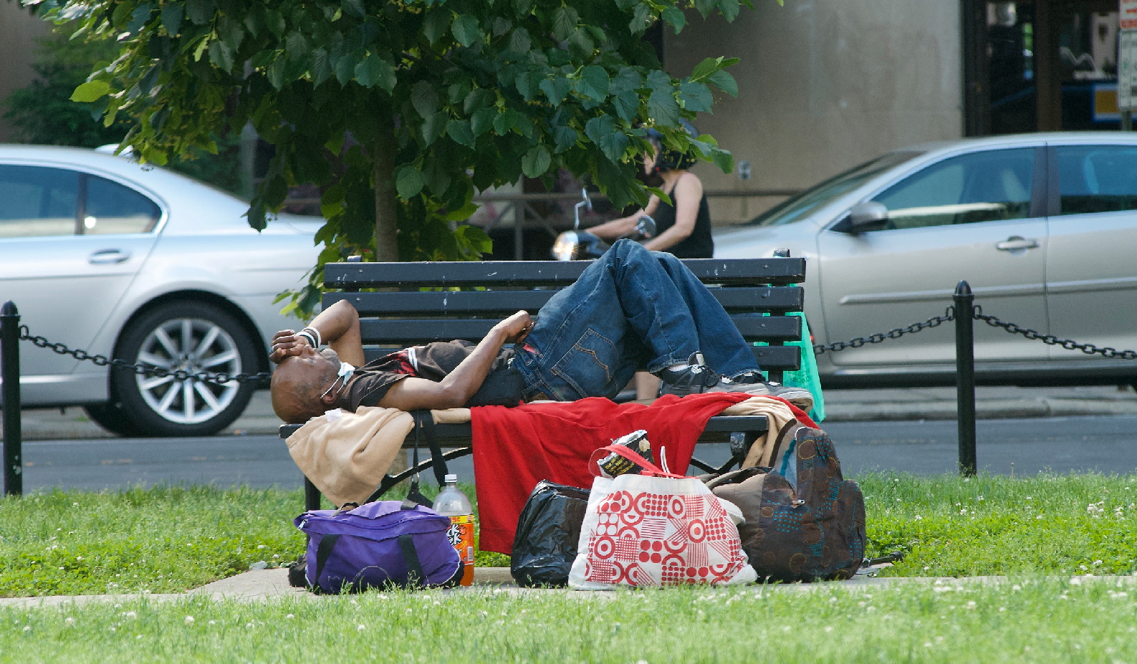
Inclusion:
HELPING PEOPLE WHO ARE AT RISK
14

  - IFRC, OCHA, WHO, “How to Include Marginalized and Vulnerable People in Risk Communication and Community Engagement”, 15 March 2020
https://reliefweb.int/report/world/covid-19-how- include-marginalized-and-vulnerable-people-risk- communication-and
  - Regional Risk Communication and Community Engagement (RCCE), “Guidance on Including Marginalized Groups in Risk Communication and
Community Engagement” https://reliefweb.int/sites/reliefweb. int/files/resources/COVID-19_ CommunityEngagement_130320.pdf
  - WHO, “Practical Considerations and Recommendations for Religious Leaders and Faith- Based Communities”
https://www.who.int/publications-detail/practical- considerations-and-recommendations-for-religious- leaders-and-faith-based-communities-in-the- context-of-covid-19

A homeless man sleeps on a bench in a park, Washington DC. By Tom Sampson

Disabilities:

- UNICEF, “Considerations for Children and Adults with Disabilities” https://www.unicef.org/disabilities/files/COVID-19_
response_considerations_for_people_with_ disabilities_190320.pdf
- CDC,“Guidance on Supporting the Needs of People with Disabilities” https://www.cdc.gov/coronavirus/2019-ncov/need-
extra-precautions/people-with-disabilities.html
- IASC, “Interim Briefing Note Addressing Mental Health and Psychosocial Aspects of COVID-19 Outbreak”
https://interagencystandingcommittee.org/iasc- reference-group-mental-health-and-psychosocial- support-emergency-settings/interim-briefing
- UNICEF, “Risk Communication and Community Engagement for COVID-19: Engaging with Children and Adults with Disabilities”
https://www.unicef.org/disabilities/files/
COVID-19 engagement_children_and_adults_ with_disabilities_final.pdf

Older adults:
  - The John A. Hartford Foundation, “Coronavirus Disease (COVID-19) Resources for Older Adults, Family Caregivers and Health Care Providers”
https://www.johnahartford.org/dissemination- center/view/coronavirus-disease-covid-19- resources-for-older-adults-family-caregivers-and- health-care-providers

People experiencing homelessness:
  - CDC, guidance on homelessness and COVID-19 https://www.cdc.gov/coronavirus/2019-ncov/ community/homeless-shelters/faqs.html and
https://www.cdc.gov/coronavirus/2019-ncov/need- extra-precautions/homelessness.html
  - OHCHR, “Protecting Those Living in Homelessness” https://www.ohchr.org/Documents/Issues/Housing/ SR_housing_COVID-19_guidance_homeless.pdf

Pregnant women and children:
  - CDC, guidance on pregnancy and breastfeeding during COVID-19 https://www.cdc.gov/coronavirus/2019-ncov/
need-extra-precautions/pregnancy-breastfeeding. html?CDC_AA_refVal
  - WHO, “Q&A: Breastfeeding and COVID-19”. https://www.who.int/news-room/q-a-detail/q-a-on- covid-19-and-breastfeeding
  - UNICEF, “Navigating Pregnancy During the Coronavirus Disease (COVID-19) Pandemic.”
  - https://www.unicef.org/coronavirus/navigating- pregnancy-during-coronavirus-disease-covid-19- pandemicCDC,“Keeping Children Healthy During
the COVID-19 Outbreak” https://www.cdc.gov/coronavirus/2019-ncov/daily- life-coping/children.html
  - UNICEF, “Protecting the Most Vulnerable Children from the Impact of Coronavirus: An Agenda for Action”
https://www.unicef.org/coronavirus/agenda-for- action

People on the move:
- WHO, “Preparedness, Prevention and Control of Coronavirus Disease (COVID-19) for Refugees and Migrants in Non-Camp Settings (Interim
Guidance)” https://data2.unhcr.org/en/documents/ details/75819
- UNHCR, “Global COVID-19 Emergency Response” http://reporting.unhcr.org/sites/ default/files/24042020_UNHCR%20Global%20
COVID-19%20Emergency%20Response.pdf
- IASC, “Interim Guidance on Scaling-up COVID-19 Outbreak in Readiness and Response Operations in Camps and Camp-like Settings” https://
interagencystandingcommittee.org/other/interim- guidance-scaling-covid-19-outbreak-readiness-and- response-operations-camps-and-camp.

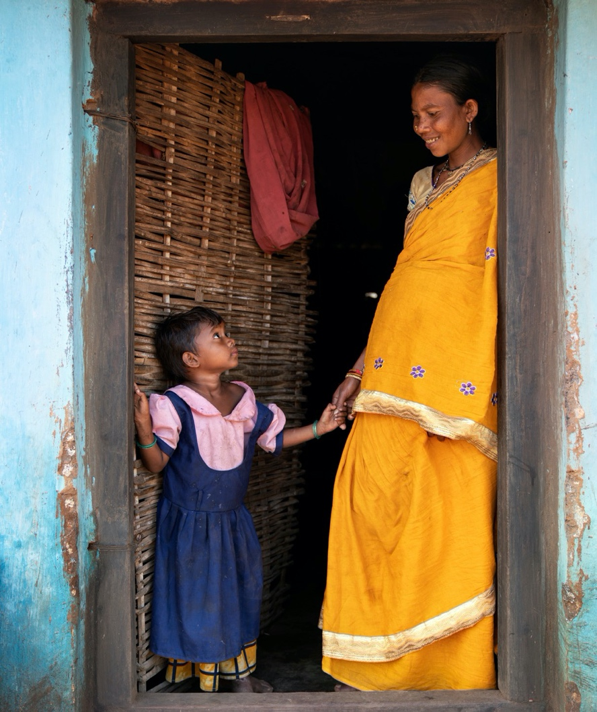

Mandari Majhi is 38 years old and has three children. She is now nine months pregnant with her 4th child.
By UNICEF/UNI296866/Narain

15

Endnotes
  - https://www.who.int/environmental_health_ emergencies/vulnerable_groups/en/
  - https://www.who.int/environmental_health_ emergencies/vulnerable_groups/en/
  - https://www.ifrc.org/en/what-we-do/disaster- management/about-disasters/what-is-a-disaster/ what-is-vulnerability/
  - https://www.cdc.gov/coronavirus/2019-ncov/need- extra-precautions/older-adults.html.
  - https://blogs.worldbank.org/impactevaluations/ what-can-low-income-countries-do-provide-relief- poor-and-vulnerable-during-covid?CID=WBW_AL_ BlogNotification_EN_EXT
  - https://ophi.org.uk/wp-content/uploads/B53_ Covid-19_vs3-2_2020_online.pdf
  - https://www.ids.ac.uk/opinions/the-impact-of- covid-19-in-informal-settlements-are-we-paying- enough-attention/ and http://blog.gdi.manchester. ac.uk/dealing-with-covid-19-in-the-towns-and- cities-of-the-global-south/
  - https://www.savethechildren.net/blog/coronavirus- devastating-blow-children-poverty
  - https://www.who.int/news-room/q-a-detail/q-a-on- covid-19-and-breastfeeding
  - https://www.unicef.org/coronavirus/navigating- pregnancy-during-coronavirus-disease-covid-19- pandemic
  - https://unsdg.un.org/resources/policy-brief-impact- covid-19-children
  - https://www.unicef.org/press-releases/children- increased-risk-harm-online-during-global-covid-19- pandemic
  - https://www.unicef.org/press-releases/futures-370- million-children-jeopardy-school-closures-deprive- them-school-meals
  - For instance, https://minorityrights.org/2020/04/29/ south-asia-minorities-report/; https://minorityrights.org/2020/04/27/statement- covid-19-pandemic-on-persons-with-disabilities- from-minority-indigenous-communities/
  - https://www.ohchr.org/EN/NewsEvents/Pages/ DisplayNews.aspx?NewsID=25757&LangID=E
  - https://endhomelessness.org/resource/fact-sheet- population-at-risk-homelessness-and-the-covid-19- crisis/

  - For example: https://www.kirkonulkomaanapu.fi/ en/latest-news/articles/refugees-coronavirus/?fbcli d=IwAR0kyYUiT18NSsu71j9ApFE7xZCAEaFc3nmm GfphocGFpgIJDPVoPD4V2mE
  - For instance, https://www.opendemocracy.net/en/ democraciaabierta/mujeres-ind%C3%ADgenas- migrantes-de-venezuela-vulnerabilidad-extrema- ante-la-covid-19-en/
  - https://carnegieendowment.org/2020/04/14/ coronavirus-in-conflict-zones-sobering-landscape- pub-81518
  - As advised, for instance by https://pda.pcusa.org/pda/resource/disease- guidance-for-congregations/
  - See, for instance, http://www.bbsi.org.uk/coronavirus/
  - Communication and monitoring strategy examples including phone trees can be found at https://www.wheaton.edu/media/humanitarian- disaster-institute/Preparing-Your-Church-for- Coronavirus.pdf p. 14
  - https://reliefweb.int/report/world/gender-matters- responding-major-disease-outbreaks-ebola
  - https://www.wheaton.edu/media/humanitarian- disaster-institute/Preparing-Your-Church-for- Coronavirus.pdf p. 14
  - Examples: https://jewishtoronto.com/global- seder; http://inebnetwork.org/activity-covid- 19-emergency-relief-fund/; https://www. salvationarmyusa.org/usn/covid19/
  - Examples: https://www.faithinplaceaction.org/
get-involved/take-action/take-action-on-covid-19/; https://faithinaction.org/news/protect-migrants- and-refugees-during-the-covid-19-pandemic/
  - Examples: https://www.helpingneighbours. com/; https://www.safinternational.org/; https:// jewishtoronto.com/global-seder
  - https://www.hias.org/covid-19-response
  - http://inebnetwork.org/activity-covid-19- emergency-relief-fund/
  - http://inebnetwork.org/statement-concerning-the- covid-19-pandemic-from-international-network-of- engaged-buddhists-ineb/
  - Example: https://www.lutheranworld.org/news/ covid-19-health-and-faith-partnership-promote- factual-information-and-reduce-fear

16

  - https://www.unicef.org/about/partnerships/ cambodia_61571.html
  - https://anglicanalliance.org/faith-in-a-time-of- covid-19-coronavirus/
  - Examples: https://mcb.org.uk/mcb-updates/ coronavirus-guidance-for-mosques-and- madrassas/; https://www.sikhcoalition. org/wp-content/uploads/2020/03/English- Recommendations-for-Gurdwaras-COVID-19- prevention-1.2.pdf
  - For example: https://www.aspeninstitute.org/ blog-posts/inclusive-america-project-response- resources-to-the-covid-19-pandemic/
  - Examples: https://tanenbaum.org/blog/2020/03/ social-supporting/; http://ihpemory.org/wp- content/uploads/2020/03/Pandemic-Hope- Devotional.pdf

17

HELPING PEOPLE WHO ARE AT RISK

JOINT CALL TO ACTION
for the Faith-in-Action COVID-19 Initiative by the UNICEF Executive Director, Henrietta Fore, and 13 of Religions for Peace’s Senior-most leaders representing diverse religious traditions:

    - Religious practices: Adapt faith gatherings, rituals, and services to ensure the safety of worshippers and develop alternative pastoral approaches.
    - Hygiene: Promote a heightened focus on handwashing, hygiene and sanitation.
    - Active listening: Listen to the experiences, needs and hopes of children and families and provide support for inter-generational dialogue.
    - Advocacy: Promote the inclusion of voices of faith and wider community engagement to inform local responses.
    - Communication and inclusion: Tackle misinformation, rumours, stigma and discrimination associated with the disease.
    - Active engagement: Engage networks of religious communities including faith-based women’s and youth organizations in collaboration with local governance structures to provide organized voluntary services.
    - Pastoral Care: Provide further spiritual and emotional care and support to bring comfort and hope for parents, children, and the elderly.
    - Parenting: Promote positive age and gender-specific parenting guidance and support to families, particularly the most vulnerable and the hardest to reach.
    - Youth engagement: Practice youth-friendly communication and engagement including more systematic use of technology and social media during periods of physical distancing and beyond.
    - Recovery: Provide support for recovery of social services.

Signatories:
Ms. Henrietta Fore, UNICEF Executive Director
Dr. Vinu Aram, Director, Shanti Ashram
Rev. Kosho Niwano, President-Designate, Rissho Kosei-Kai
H.E. Shaykh Abdallah bin Bayyah, President, Forum for Peace in Muslim Societies, Abu Dhabi
H.E. Metropolitan Emmanuel, Metropolitan of France, Ecumenical Patriarchate
Ms. Bani Dugal, Principal Representative to the UN, Bahá’í International Community
Mr. Homi Gandhi, President, Federation of Zoroastrian Associations of North America
The Most Rev. Antje Jackelen, Archbishop of Uppsala, Primate of Sweden, Church of Sweden
H.E. Sheikh Shaban Ramadhan Mubaje, Grand Mufti, Uganda
H.E. John Cardinal Onaiyekan, Archbishop Emeritus of Abuja, Nigeria
Ms. Aruna Oswal, Vice-President, World Jain Confederation
Grand-Father Dominique Rankin, Algonquin Hereditary Grand Chief
Chief Rabbi David Rosen, KSG CBE, International Director of Interreligious Affairs, American Jewish Committee
Bhai Sahib Mohinder Singh, OBE KSG, Chairman, Guru Nanak Nishkam Sewak Jatha https://rfp.org/launch-of-global-multi-religious-faith-in-action-covid-19-initiative/

18

HELPING PEOPLE WHO ARE AT RISK

