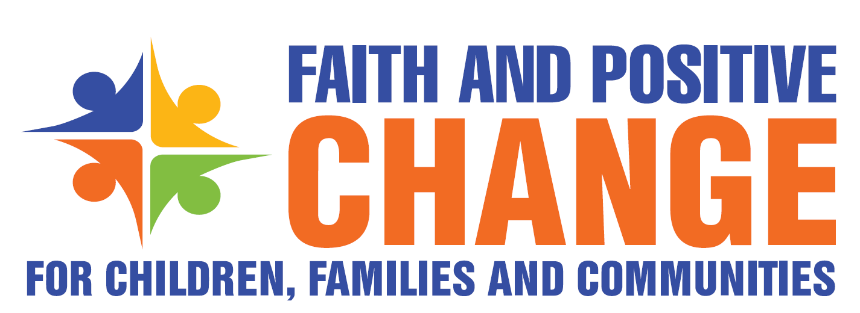

EXAMPLE OF TERMS OF REFERENCE
Faith Partners Advisory Group

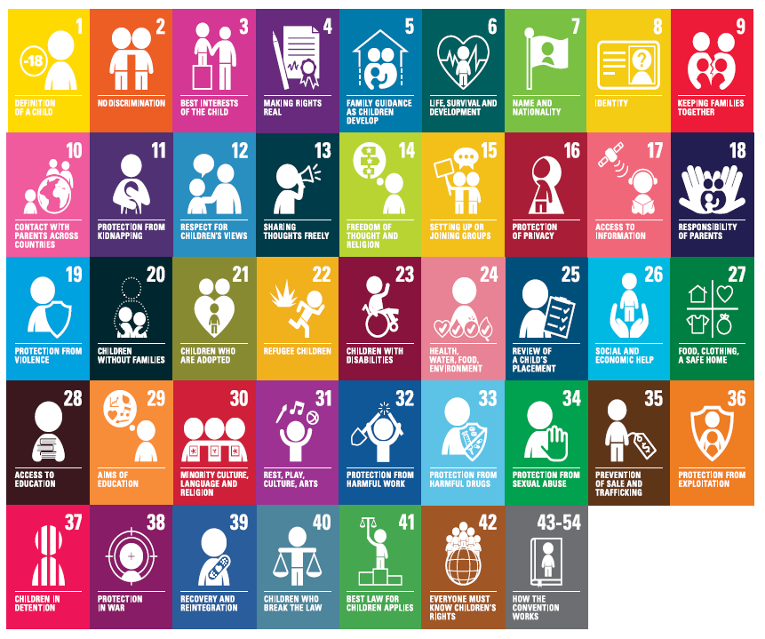

- Rationale and Background
Although one of the most powerful influencers of individual behaviours, social norms and collective action at community and societal level is religion, UNICEF partnership strategies with religious groups and FBOs have seldom brought together the range of engagement possibilities at country level in a systematic way necessary to effect sustainable change in complex behaviours and social norms that affect a range of child health, protection and development outcomes. UNICEF partnerships with Religious communities and FBOs have largely been developed by single sectors around specific activities in project and often instrumentalist mode, versus a more strategic, overarching and principle-based programming framework tied to country programme priorities and to the holistic well-being of children and youth. Furthermore religious groups and FBOs themselves seek a more collaborative, less instrumentalizing holistic partnership with UNICEF for long term community systems strengthening and child well-being.
[insert text about your faith engagement]

- Goal
The overall goal of this Faith Partners Advisory Group is to: promote partnerships and opportunities in support of the roll out of strategies and approaches for Faith and Positive Change for Children, Families and Communities (FPCC) in [Region’s name]. The aim of the Group is to reduce transaction costs for local faith actors, surface and mitigate barriers, share knowledge emerging from experiences and develop and support monitoring, evaluation and learning for the initiative to inform continual improvement of the partnership model and application towards the role of faith in improving the lives of children, families and communities in the countries of the region.

- Main Objectives and Lines of Action

  - High Level Advocacy
Continue to convene high level religious leaders as an alliance to strengthen the commitment of religious communities, and faith-based organizations to use their moral influence and leadership networks and influence to promote child rights and SDG targets, develop common positions on sensitive issues and promote social inclusion for children, harmony amongst religious groups and concrete results for children on commonly defined priority regional headline results.

  - Regional Partner Coordination
Identify and support opportunities to maximize complementarity, efficient use of resources and reduce burden on local faith actors by mapping of existing mechanisms, networks, resources, approaches and initiatives supporting Faith engagement for children, families and communities; and joint development of priorities and plans of action amongst faith partners and development partners.

  - Country Level Coordination
Promote and guide the establishment of MFACCs (Multi-Faith Action Committees for Children), inclusive of all religious groups and faith actors, as the main coordinating mechanism at country level for faith engagement related to children, families and communities within existing country level Inter-Faith coordinating structures (with linkage to any prior existing faith networks for children) and with establishment of systematic engagement other wider CSO and national government-led coordination mechanisms for children. Promote the development of MFACC Plans of Action with the embedding of activities and budgets for implementation within respective partner annual workplans.

  - Capacity Development
Support establishment and roll out of a coordinated long-term partnership training model for Country level FPCC stakeholders to ensure embedding of the foundational faith engagement approach of Mind-Heart dialogue integrated with technical information and skills on child rights issues in respective partners faith engagement work. This will include building on existing capacities of religious leaders, women and youth faith networks and FBO personnel to establish a pool of master trainers, country trainers and facilitators and implementation of religious literacy training for UNICEF/development partner staff to ensure mutual transformation on faith engagement across all programme sectors and embedding of faith engagement in the programme cycle.

  - Regional Resources and Tools
Support the adoption, adaptation, translation, development and promotion of technical resources/tools for use across the region, (including reviews and validation of thematic guides by religious scholars/theologians) to ensure mutually acceptable, harmonized and quality approaches on faith engagement for children, families and communities.

  - Knowledge Management and exchange
Collaborate on documentation and dissemination of strategic country level faith engagement initiatives (through joint publications, case studies, annual retreats, etc.) to promote learning on strengths and gaps of current faith engagement partnerships and strengthening and scaling up of best practices.

  - Research, Monitoring and Evaluation
Support increased and improved generation and use of evidence related to faith engagement aimed at child, family and community development wellbeing and support application and refinement of the FPCC Monitoring and Evaluation Framework to evaluate the quality and effectiveness of faith-based initiatives at both country and regional levels.

- Membership
The three arms of the tripartite partnership (religious leaders including Religions for Peace (RfP) council members and other religious leaders; FBO members of the Joint Learning Initiative on Faith and Local Communities (JLI), and selected Regional and Country office representatives from UNICEF shall appoint their staff to represent their various organizations. The Advisory Group shall have the following members:

3 co-chairs/co-convenors to rotate convening roles
    - 8 Nominated representatives from JLI FBOs
    - 8 Nominated representatives from Religions for Peace Regional offices and other religious leaders
    - 8 Nominated representatives from UNICEF Regional and Country Offices

- Core Group
The FPCC Advisory Group will appoint 3 co-chairs – one from each of the respective tripartite agencies (RfP/Religious leaders, FBOs, UNICEF) who will serve as the core group with each of the 3 partners serving as Chair for meetings on a rotational basis.

- Task Groups and Co-option
When necessary and, the AG will periodically establish time-bound Task Groups to accomplish major streams of work. Where the AG or Task Groups are of the view that a technical expert in a certain area of need is desired, that person may be co-opted to the AG for that specific task.

- Meetings
The Full AG shall meet quarterly as per the scheduled meetings (3 meetings by conference call and one in-person if possible) and with the following expectations:
- The secretary of the AG shall in consultation with the Convener facilitate the meeting to take place, including preparation of links and other logistics/administrative aspects.
- Where necessary, sub-committees/task groups of the AG will meet as per the requirement and plan.
- AG decisions will be made on the basis of the majority of the members present.
- Resolutions of the AG shall be passed in writing and by consensus.
- The AG members will be asked to pre-read documents prior to the conference calls and will be invited to consult with their own networks and provide collective feedback before and after each meeting.
- The AG will be asked to complete short surveys prior to FPCC calls as way of gathering and synthesizing inputs for collective discussion.

- Quorum
A quorum shall consist of a minimum of 4 representatives from each of the three tripartite partners.

- Support to the Advisory Group

UNICEF will provide Secretariat support to the Advisory Group including preparing pre-read materials, recording AG members’ inputs, and providing logistical support for any in-person meetings.

Annex 1
Background on FPCC Global Initiative

With the goal of establishing more strategic, sustainable and effective partnerships with Religious leaders, local Faith communities and FBOs through a new way of working that is more collaborative, community asset-based, integrated, and wholistic, UNICEF in 2018, in partnership with the world’s largest convenor of faiths Religions for Peace (RfP) and knowledge partner and member organization of FBOs, Joint Learning Initiative (JLI) launched a new initiative - Faith and Positive Change for Children, Families and Communities (FPCC) initiative. The aim of the initiative is to support evidence-based integrated framework for faith-based leadership for SBC and faith influence for positive change.

In 2019, the FPCC Theory of Change and Mind-Heart Dialogue foundational approach was developed, tested, adapted and validated in 5 country Workrocks in Easterm, Southern and West Central Africa, and in consultation with the FPCC Advisory group including representatives from the tripartite partners. A WorkRock is a concept for an in-depth consultation and planning meeting with Faith partners as the foundation for a new way of working on strategic faith engagement.

In 2020, FPCC in response to the global COVID-19 Pandemic, re-purposed its workplan to launch a global Faith-in-Action initiative to address 6 priorities of the pandemic: Addressing Misinformation and Rumours; Stigma and Discrimination; Adaptation of Mass Gatherings and Rituals; Violence Against Children; Addressing Vulnerable Groups; Children and Youth Participation and Supporting Recovery of Social Services. Supported by the tri-partite partnership (RfP, JLI and UNICEF, a series of 7 Regional webinars and one global FBO consultation webinars were convened to learn about existing efforts, issues and needs related to the pandemic and to make plans. A set of 6 global guidance document on the priority issues were co-created and a virtual WorkRock training series developed and piloted with RfP Inter-religious councils, FBOs and UNICEF in 6 countries Eastern and Southern Africa to train religious leaders and FBOs to roll out the FPCC approach, supported by Global Guidance documents, resources and a technical team from JLI.

In 2021, in collaboration with a Faith-based training institute CORAT, a FPCC training model was developed and implemented by the tripartite partnership, focusing on Regional Master training in ESAR and WCAR regions using the Mind-Heart Dialogue Facilitators manual, followed by country level WorkRocks in 8 selected countries.

The follow-up and complement to the roll out these trainings is a focus on establishment of national mechanisms (Multi-Religious Faith Action Committees for Children) building on Inter-Religious Councils and local FBOs (including country offices of international FBOs) to plan and coordinate Faith engagement for children, families and communities.
See draft MFACC Draft Terms of Reference.

FPCC has also developed a draft Monitoring, Evaluation and Learning Framework which has been piloted in two countries and is to be refined for further use to assess the level of change influenced by FPCC in relation to; 1) Partnerships and Coordination 2) application of the Mind-Heart Dialogue approach 3) change in the lives of children, families and communities.

Annex 2
[insert background on your religious engagement]

